Date: 30 September 2022

REQUEST FOR QUOTATION
RFQ Nº UNFPA/KHM/RFQ/22/017

Dear Sir/Madam,

UNFPA hereby solicits a quotation for the following service:

“16 Days GBV Services Fair to increase awareness and promote key intervention messages to address harmful gender/GBV social norms”

UNFPA requires the provision of “16 Days GBV Services Fair to increase awareness and promote key intervention messages to address harmful gender/GBV social norms”.

- About UNFPA

UNFPA, the United Nations Population Fund (UNFPA), is an international development agency that works to deliver a world where every pregnancy is wanted, every childbirth is safe and every young person’s potential is fulfilled.

UNFPA is the lead UN agency that expands the possibilities for women and young people to lead healthy sexual and reproductive lives. To read more about UNFPA, please go to: UNFPA about us

Service Requirements/Terms of Reference (ToR)

Objectives and Scope of the Services

Background Information

The 16 Days of Activism against Gender-Based Violence (GBV) is an international campaign, which takes place every year commencing from 25 November, the International Day for the Elimination of Violence against Women, until 10 December, Human Rights Day. The Ministry of Women’s Affairs takes the lead in organizing the 16 Days of Activism to end Gender Based Violence against Women and Girls in Cambodia every year.

GBV is a significant issue for many women and young girls around the globe. According to the World Health Organization (WHO), 30% of women worldwide have experienced GBV, or any harmful act that is perpetrated against a person’s will and based on socially ascribed (gender) differences between males and females. GBV includes sexual intimate partner violence (IPV), non-partner sexual violence, domestic violence, trafficking, forced or early marriage, and harmful practices. The WHO asserts that GBV may have increased during the ongoing COVID-19 pandemic as lockdown and its social and economic impacts increased women’s exposure to abusive partners and GBV risk factors. GBV is known to increase during crises, and older women, women with disabilities, women who are displaced, and refugees are likely to face additional risks.

The situation around GBV is similar in Cambodia, where 30.8% of women between the ages of 15-49 years old have experienced physical, sexual, emotional, economic, or intimate partner violence in their lifetime. From this number, at least 25% experienced emotional IPV, 6% experienced economic IPV, 16% faced physical IPV, and 6% reported sexual IPV. A 2020 youth situation analysis indicates that around 12% of youth experienced a form of abuse in the past 12 months, whereby 14% of males and 10% of females reported that they were physically abused.

Social norms and beliefs that restrict what women can do and be, and give higher value and more power to men, are still pervasive. These norms are reflected in the vastly unequal distribution of unpaid domestic and care work, which in turn constrains women’s opportunities and resources. Harmful gender norms are also a root cause of gender-based violence which directly affects a significant proportion of Cambodian women and LGBTQI and has a ‘chilling effect’ on others, discouraging them from accessing certain spaces or standing up for their rights.

UNFPA Cambodia’s participation in the 16 Days of Activism against GBV is part of the national campaign led and coordinated by the Ministry of Women's Affairs. UNFPA’s participation is funded through the Australian Government ACCESS program. Other UN agencies and civil society organizations are also participating. The campaign includes an outreach and digital campaign through Facebook TikTok, YouTube and Twitter to show organisational participation and community solidarity to prevent and eliminate all forms of violence against women and girls.

Objectives

During the 16 Days Campaign for 2022, UNFPA will focus on reaching specific groups that have traditionally been hard to reach including young people. Overall objectives will be to increase access to information about GBV support and services, as well as increasing awareness about the harms of GBV as a means of addressing harmful social norms in order to promote positive behaviour change. Target groups will be survivors of violence, as well as the general public for positive social norm behaviour change. Specific objectives for this 16 Days campaign, in alignment with the regional GBV and United Nations Secretary-General’s campaign on service providers under the global theme “UniTE! Activism against gender-based violence women & girls now” will be to:

- Increase access to information about services and support for hard to reach groups (refer below)
- Highlight the services available for those hard to reach groups including psychological counseling, reproductive health, and other social services.
- Promote and provide information on service providers (the main list is attached in the annex and other list of service providers will be distributed by MoWA and other agencies)
- Feature the work of service providers in order to ensure that the public and specific groups know what service providers in GBV do, and to learn more about the role of service providers
- Provide disability friendly messaging and specific messaging for LGBTIQA+ communities

Target Audiences

- Women and girls at high-risk of GBV and sexual harassment including;
  - Garment factory workers who are most vulnerable and at risk of GBV and sexual harassment
  - The most vulnerable groups not limited to people with disabilities, LGBTQIA+
- Women and young girls, and Youth.

Planned Timelines

- Start Date: 20 November 2022
- End Date: 31 December 2022

KEY MESSAGES:
Primary Messages:

- Violence against women and girls is a grave violation of human rights
- There are a range of services available for helping those that are experiencing violence – service providers include counselors, nurses, police etc.
- As the public, we need to support those experiencing violence. We can do this by: sharing information on services, helping those that are experiencing violence to access services, and by reporting violence. Violence against women and girls is everyone’s responsibility.

Secondary Messages:

- Violence against women and girls is a gross violation of human rights
- If you are experiencing violence, remember, it is not your fault and there are services available to support you
- Services available include including psychological counseling, reproductive health, police, justice, and other social services
- Service hotline numbers – 1288 (police), 1280 (Child Helpline Cambodia)
- If you are experiencing violence, there are services information to help and advise you – call (MoWA: 093 777 900, 085 777 900) or (TPO: 010 222 478/017 222 372/ 097 9111 918) and speak with a confidential counselor
- Violence against women and girls harms not only women and girls, but our whole society and we must have zero tolerance for violence – We will continue our efforts until every woman and girl is free and safe from all forms of violence
- Speak out! We (MoWA and social service providers) are here to support you!

Expected Results

After the 16 days of Activism to end violence against women and girls’ campaign, it is expected that there will be a greater understanding amongst the general population of the services available and about how to access psychological counseling and reproductive health services. It is also expected that specific target groups such as factory workers, persons with disabilities and youth have greater knowledge of the support and services available. The result of this campaign should lead to an increase in the number of people seeking out services from service providers.

Baseline: data obtained in the first 6 months of 2022:

20 (Hotline of TPO- psychological counseling)
62 GBV Cases (helpline MoWA)

Scope of Work and Deliverables

Scope of Work:

The contractor/vendor will be expected:

- To develop creative concepts based upon UNFPA provided and approved key messages for 16 Days GBV Services Fairs including exhibition design stage, booths, develop and produce need-based printed materials, storyboards for stage performance, scripts in line with the 16 days GBV SM Campaign feel and look and key messages.
- To provide a talent list including MC, Signer, Performance Team for selection and approval and submit the final report of the campaign coverage and recommendation including soft design artworks, materials, images and videos from the event.

The 16 Days Services Fair Includes: One full day

16 Days GBV Services Fair (Full day from 9:00 am to 8:00 pm) – the date is TBD (preferable 27th November). A full programme will be developed jointly with the MoWA and partners however the initial idea is to undertake the following. Submit the final Event Report and Coverage.

Exhibition/Fair: (Full day from 9:00 am to 8:00 pm)
- MC/VJ perform, mutual talk, play song, singing and performing show and quiz
- Education and services provider Booths at the Mall common areas in collaboration with MoWA, CSOs, and UN agencies (like ILO, UNODC, UNRC) with open-setting booths - Maximum 12 booths (3m x 3m)
- Two close-setting booths – mobile clinic concept: One booth for women health checkup in collaboration with MSI/C and one more booth for Mental Health counseling in collaboration with TPO
- Photo booth (auto printed photo) for audiences at the event

Opening Session and Performance (180mn 3:00pm – 6:00 pm)
- 60 mins Opening Remarks Session by MoWA, UNFPA, UN Agencies and Other CSOs – Set up on the platform with campaign backdrop
- 90 mins VJ, Singing and performing show (by popular performance team, singer, VJ and MC)
- 30 mins Quiz shows on the stage with small gifts (Merchandise from UNFPA)
- Promoting the concert on SM Platforms, before-during the event
- Live 90 mins opening session on Social Media Platforms (UNFPA FB Page, MoWA FB Page, Other UN Agencies FB pages)

Deliverable:

UNFPA, the Ministry of Women’s Affairs, CSOs and other UN agencies will co-organize a one day 16 Days of Activism against GBV Services Fair targeting garment factory workers located in the outskirt of Phnom Penh (K Mall – Community Mall) to raise awareness on GBV/VAW, gender social norms, sexual harassment, and prohibited conducts against women and girls. The finished and approved materials for social media and Services Fair are to be delivered by 24 November and scheduled to be on the social media platforms and mini-concert performance by 25 November onwards. A professional “MC” will be hired to keep the crowds entertained – and this MC will be briefed with information and key messages about the 16 Days of Activism campaign. A video screen can also display video messages throughout the day. The day event will be formally opened by the Minister for Women’s Affairs and feature speakers from UNFPA and service providers. Other UN agencies will be invited to participate.

Qualifications and Requirements

- Experience working with UN agencies in Cambodia with existing Long-Term Agreement (LTA) preferable;
- At least five-year experience in developing messages for social media platform and other media outlets with proven records of organizing service fairs;
- At least three-year experience in sexual, reproductive and maternal health messaging development;
- Demonstrate sound existing platform and networks to ensure wider reach to women across the country;
- Demonstrate sound technical team and availability to meet the deadline

- Questions

Questions or requests for further clarifications should be submitted in writing to the contact person below:

Name of contact person at UNFPA: | Ms. Suzana Sorinchan,  Programme Specialist, Advocacy & Partnerships
Tel Nº: | +855 23 215519-118
Mobile Nº: | +855 92 393 944
Email address of contact person: | sorinchan@unfpa.org

The deadline for submission of questions is Friday 7 October 2022 at 3 p.m. Phnom Penh time. Questions will be answered in writing and shared will parties as soon as possible after this deadline.

- Eligible Bidders
This Request for Quotation is open to all eligible bidders; to be considered an eligible bidder for this solicitation process you must comply with the following:

- A bidder must be a legally-constituted company that can provide the requested products/services/works [– select appropriate and delete the rest] and have legal capacity to enter into a contract with UNFPA to deliver/perform [- select appropriate and delete the rest] in the country, or through an authorized representative.
- A bidder must not have a conflict of interest regarding the solicitation process or with the TORs / Technical Specifications. Bidders found to have a conflict of interest shall be disqualified.
- At the time of Bid submission, the bidder, including any JV/Consortium members, is not under procurement prohibitions derived from the Compendium of United Nations Security Council Sanctions Lists and has not been suspended, debarred, sanctioned or otherwise identified as ineligible by any UN Organization or the World Bank Group.
- Bidders must adhere to the UN Supplier Code of Conduct, which may be found by clicking on UN Supplier Code of Conduct.

- Content of quotations

Quotations should be submitted via a TWO-envelope system. Interested Bidders are requested to submit their Technical Bid separately from their Financial Bid containing the price information. Each envelope shall consist of a single email whenever possible, depending on file size.

- Technical proposal, in response to the requirements outlined in the service requirements / TORs.
- Price quotation, to be submitted strictly in accordance with the price quotation form.

- Instructions for submission

Proposals should be prepared based on the guidelines set forth in Section III above, along with a properly filled out and signed price quotation form, and are to be sent by email to the contact person indicated below no later than: Friday, 14 October 2022 at 5 p.m. Phnom Penh Time.

Name of contact person at UNFPA: | Mr. Sophoan Livan
Email address of contact person: | Cambodia Procurement <cambodia-procurement@unfpa.org>

Please note the following guidelines for electronic submissions:

- The following reference must be included in the email subject line: - UNFPA/KHM/RFQ/22/017 “16 Days GBV Services Fair to increase awareness and promote key intervention messages to address harmful gender/GBV social norms”—Company Name, Technical Bid.
- UNFPA/KHM/RFQ/22/017 “16 Days GBV Services Fair to increase awareness and promote key intervention messages to address harmful gender/GBV social norms”—Company Name, Financial Bid.
- Submissions without this text in the email subject line may be rejected or overlooked and therefore not considered.
- It is the Bidder’s responsibility to assure compliance with the submission process. If the envelopes or emails are not marked / submitted per the instructions, UNFPA will neither assume responsibility for the bid’s misplacement or premature opening nor guarantee the confidentiality of the Bid process. Incorrect submissions might result in your Bid being declared invalid.
- The total email size may not exceed 20 MB (including email body, encoded attachments and headers). Where the technical details are in large electronic files, it is recommended that these be sent separately before the deadline.
- Any quotation submitted will be regarded as an offer by the bidder and does not
constitute or imply the acceptance of any quotation by UNFPA. UNFPA is under no obligation to award a contract to any bidder as a result of this RFQ.

- Overview of Evaluation Process
The evaluation will be carried out in a two-step process by an ad-hoc evaluation panel. Technical proposals will be evaluated and scored first, prior to the evaluation and scoring of price quotations.

Technical Evaluation

Technical proposals will be evaluated based on their responsiveness to the service requirements /TORs listed in Section II and in accordance with the evaluation criteria below.

Criteria | [A] Maximum Points | [B]  Points attained by Bidder | [C]  Weight (%) | [B] x [C] = [D]  Total Points
Technical approach, methodology and level of understanding of the objectives of the project | 100 |  | 20%
Work plan/time scales given in the proposal and its adequacy to meet the project objectives | 100 |  | 20%
Professional experience of the staff that will be employed to the project proving demonstrated expertise in evaluation and related processes (CVs, etc.) | 100 |  | 15%
Specific experience and expertise relevant to the assignment | 100 |  | 30%
Profile of the company and relevance to the Project. | 100 |  | 15%
Grand Total All Criteria | 500 |  | 100%

The following scoring scale will be used to ensure objective evaluation:

Degree to which the Terms of Reference requirements are met based on evidence included in the Bid submitted | Points  out of 100
Significantly exceeds the requirements | 90 – 100
Exceeds the requirements | 80 – 89
Meets the requirements | 70 – 79
Partially meets the requirements | 1 – 69
Does not meet the requirements or no information provided to assess compliance with the requirements | 0

Financial Evaluation

Price quotes will be evaluated only for bidders whose technical proposals achieve a minimum score of 70 points in the technical evaluation.

Price quotes will be evaluated based on their responsiveness to the price quote form. The maximum number of points for the price quote is 100, which will be allocated to the lowest total price provided in the quotation. All other price quotes will receive points in inverse proportion according to the following formula:

Financial score = | Lowest quote ($) | X 100 (Maximum score)
 | Quote being scored ($)

Total score
The total score for each proposal will be the weighted sum of the technical score and the financial score. The maximum total score is 100 points.

Total score 70% Technical score + 30% Financial score

- Award Criteria
In case of a satisfactory result from the evaluation process, UNFPA intends to award a Professional Service Contract on a fixed-cost basis with duration of two (02) months to the Bidder(s) that obtain the highest score.

- Right to Vary Requirements at Time of Award
UNFPA reserves the right at the time of award of contract to increase or decrease, by up to 20%, the volume of services specified in this RFQ without any change in unit prices or other terms and conditions.

- Payment Terms
UNFPA payment terms are net 30 days upon receipt of invoice and delivery/acceptance of the milestone deliverables linked to payment as specified in the contract.

- Fraud and Corruption
UNFPA is committed to preventing, identifying, and addressing all acts of fraud against UNFPA, as well as against third parties involved in UNFPA activities. UNFPA’s Policy regarding fraud and corruption is available here: Fraud Policy. Submission of a proposal implies that the Bidder is aware of this policy.

Suppliers, their subsidiaries, agents, intermediaries and principals must cooperate with the UNFPA Office of Audit and Investigations Services as well as with any other oversight entity authorized by the Executive Director and with the UNFPA Ethics Advisor as and when required. Such cooperation shall include, but not be limited to, the following: access to all employees, representatives agents and assignees of the vendor; as well as production of all documents requested, including financial records. Failure to fully cooperate with investigations will be considered sufficient grounds to allow UNFPA to repudiate and terminate the Agreement, and to debar and remove the supplier from UNFPA's list of registered suppliers.

A confidential Anti-Fraud Hotline is available to any Bidder to report suspicious fraudulent activities at UNFPA Investigation Hotline.

- Zero Tolerance
UNFPA has adopted a zero-tolerance policy on gifts and hospitality. Suppliers are therefore requested not to send gifts or offer hospitality to UNFPA personnel. Further details on this policy are available here: Zero Tolerance Policy.

- RFQ Protest
Bidder(s) perceiving that they have been unjustly or unfairly treated in connection with a solicitation, evaluation, or award of a contract may submit a complaint to the UNFPA Representative, Ms. Sandra Bernklau at bernklau@unfpa.org Should the supplier be unsatisfied with the reply provided by the UNFPA Representative, the supplier may contact the Chief, Supply Chain Management Unit at procurement@unfpa.org.

- Disclaimer
Should any of the links in this RFQ document be unavailable or inaccessible for any reason, bidders can contact the Procurement Officer in charge of the procurement to request for them to share a PDF version of such document(s).

PRICE QUOTATION FORM

Name of Bidder:
Date of the quotation: | Click here to enter a date.
Request for quotation Nº: | UNFPA/KHM/RFQ/22/017
Currency of quotation: | USD
Delivery charges based on the following 2010 Incoterm: | Choose an item.
Validity of quotation:
(The quotation shall be valid for a period of at least 3 months after the submission deadline.)

- Quoted rates must be exclusive of all taxes, since UNFPA is exempt from taxes.

Item | Description | Number & Description of Staff by Level | Hourly Rate | Hours to be Committed | Total
- Professional Fees
Total Professional Fees |  |  |  |  | $$
- Out-of-Pocket expenses
Total Out of Pocket Expenses |  |  |  |  | $$
Total Contract Price  (Professional Fees + Out of Pocket Expenses) |  |  |  |  | $$
Vendor’s Comments:

I hereby certify that the company mentioned above, which I am duly authorized to sign for, has reviewed RFQ UNFPA/KHM/RFQ/22/017 including all annexes, amendments to the RFQ document (if applicable) and the responses provided by UNFPA on clarification questions from the prospective service providers. Further, the company accepts the General Conditions of Contract for UNFPA and we will abide by this quotation until it expires.
 | Click here to enter a date.
Name and title | Date and place

ANNEX I:
General Conditions of Contracts:
De Minimis Contracts

This Request for Quotation is subject to UNFPA’s General Conditions of Contract: De Minimis Contracts, which are available in: English, Spanish and French

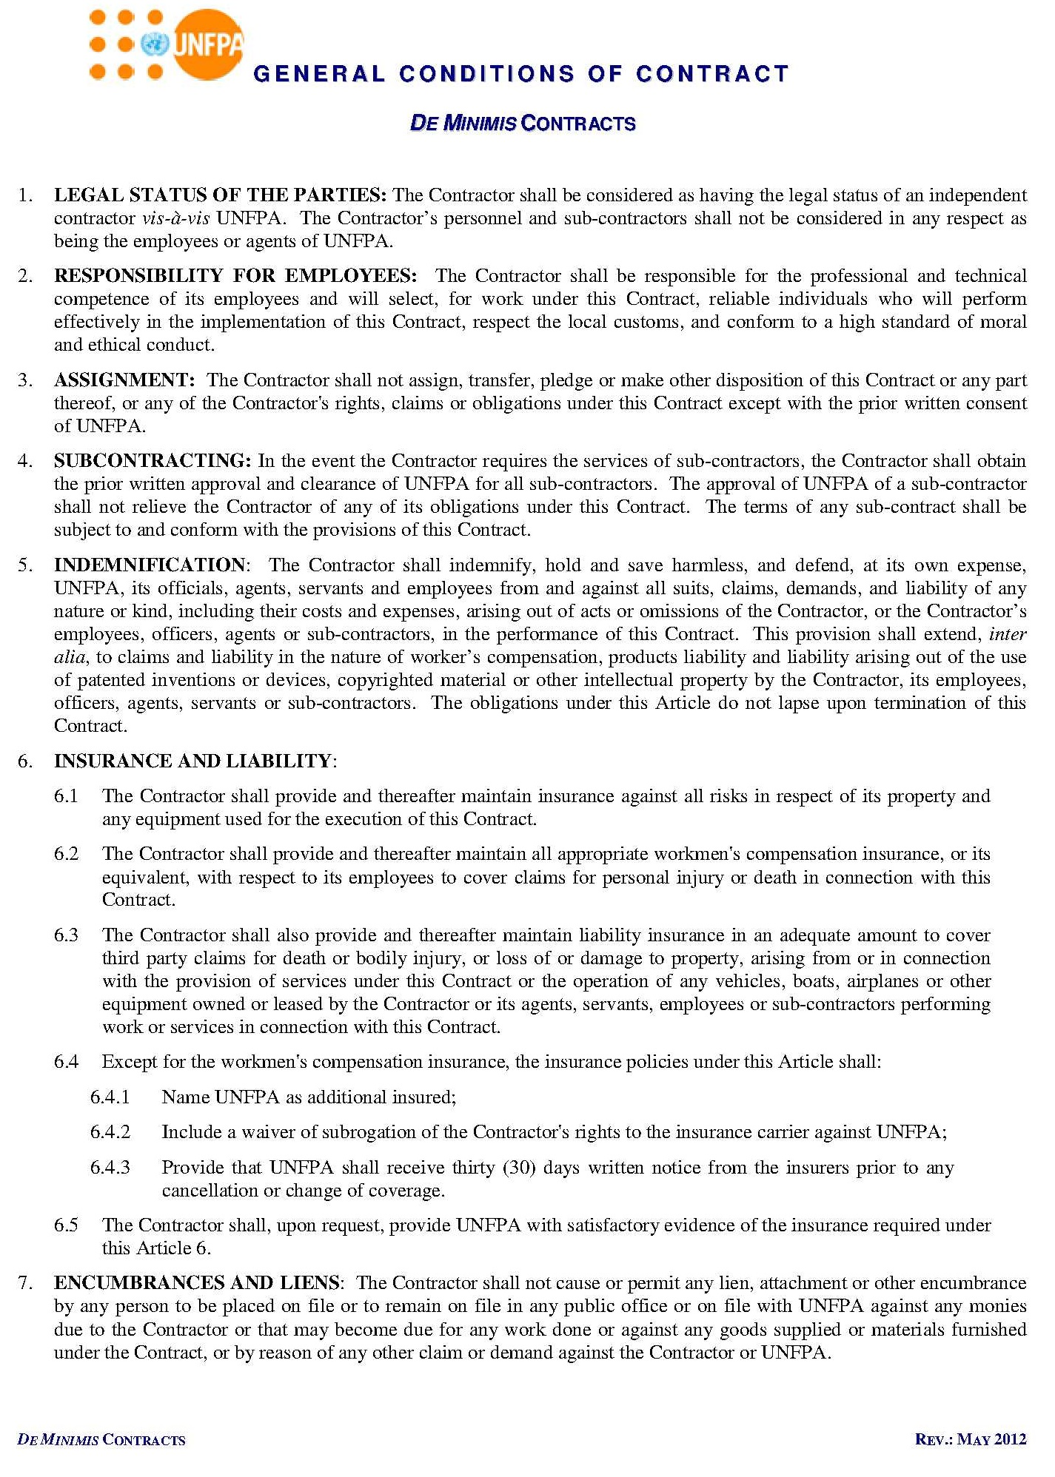
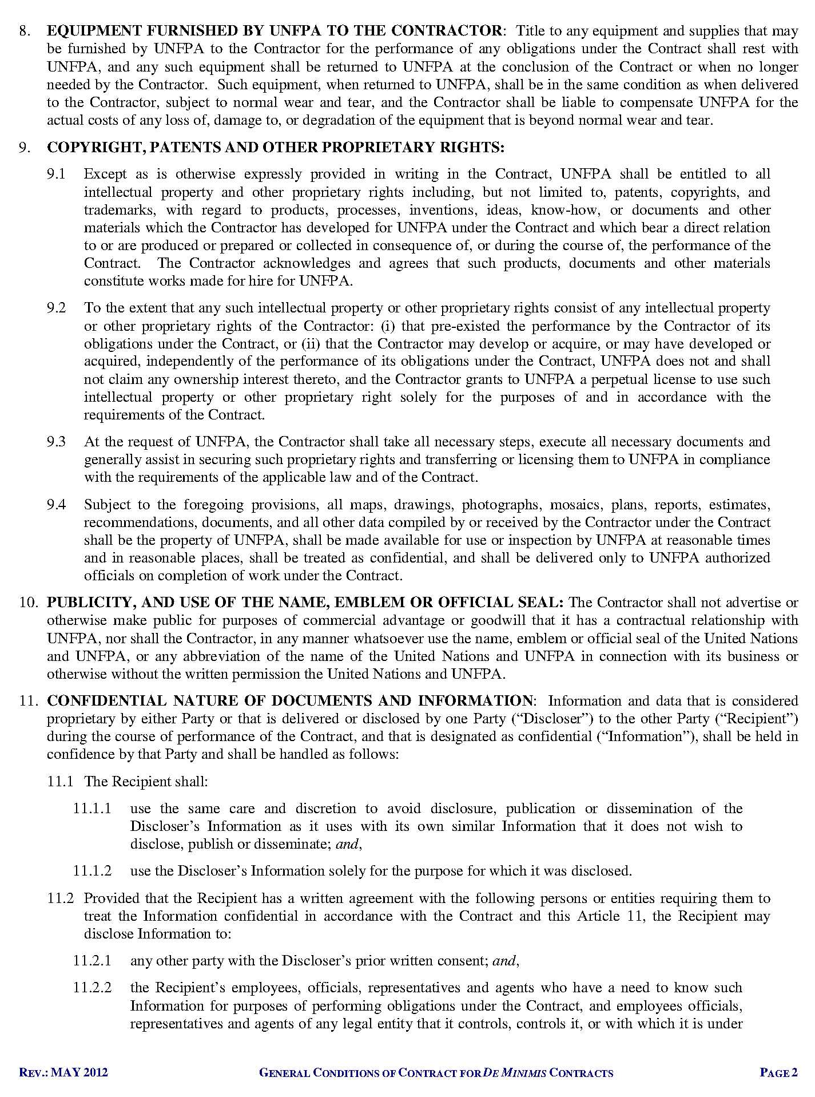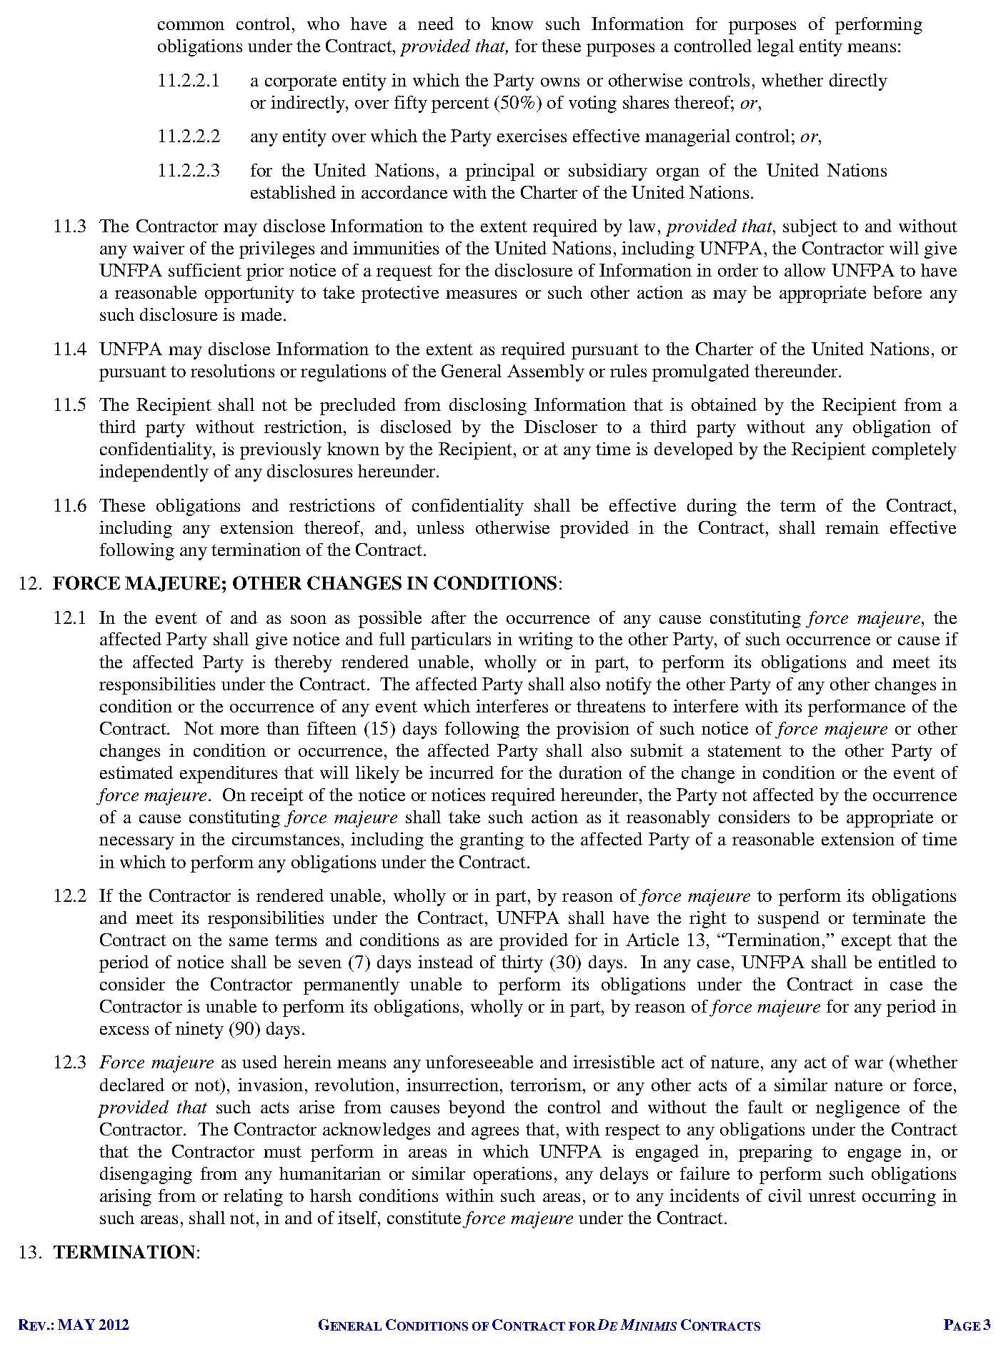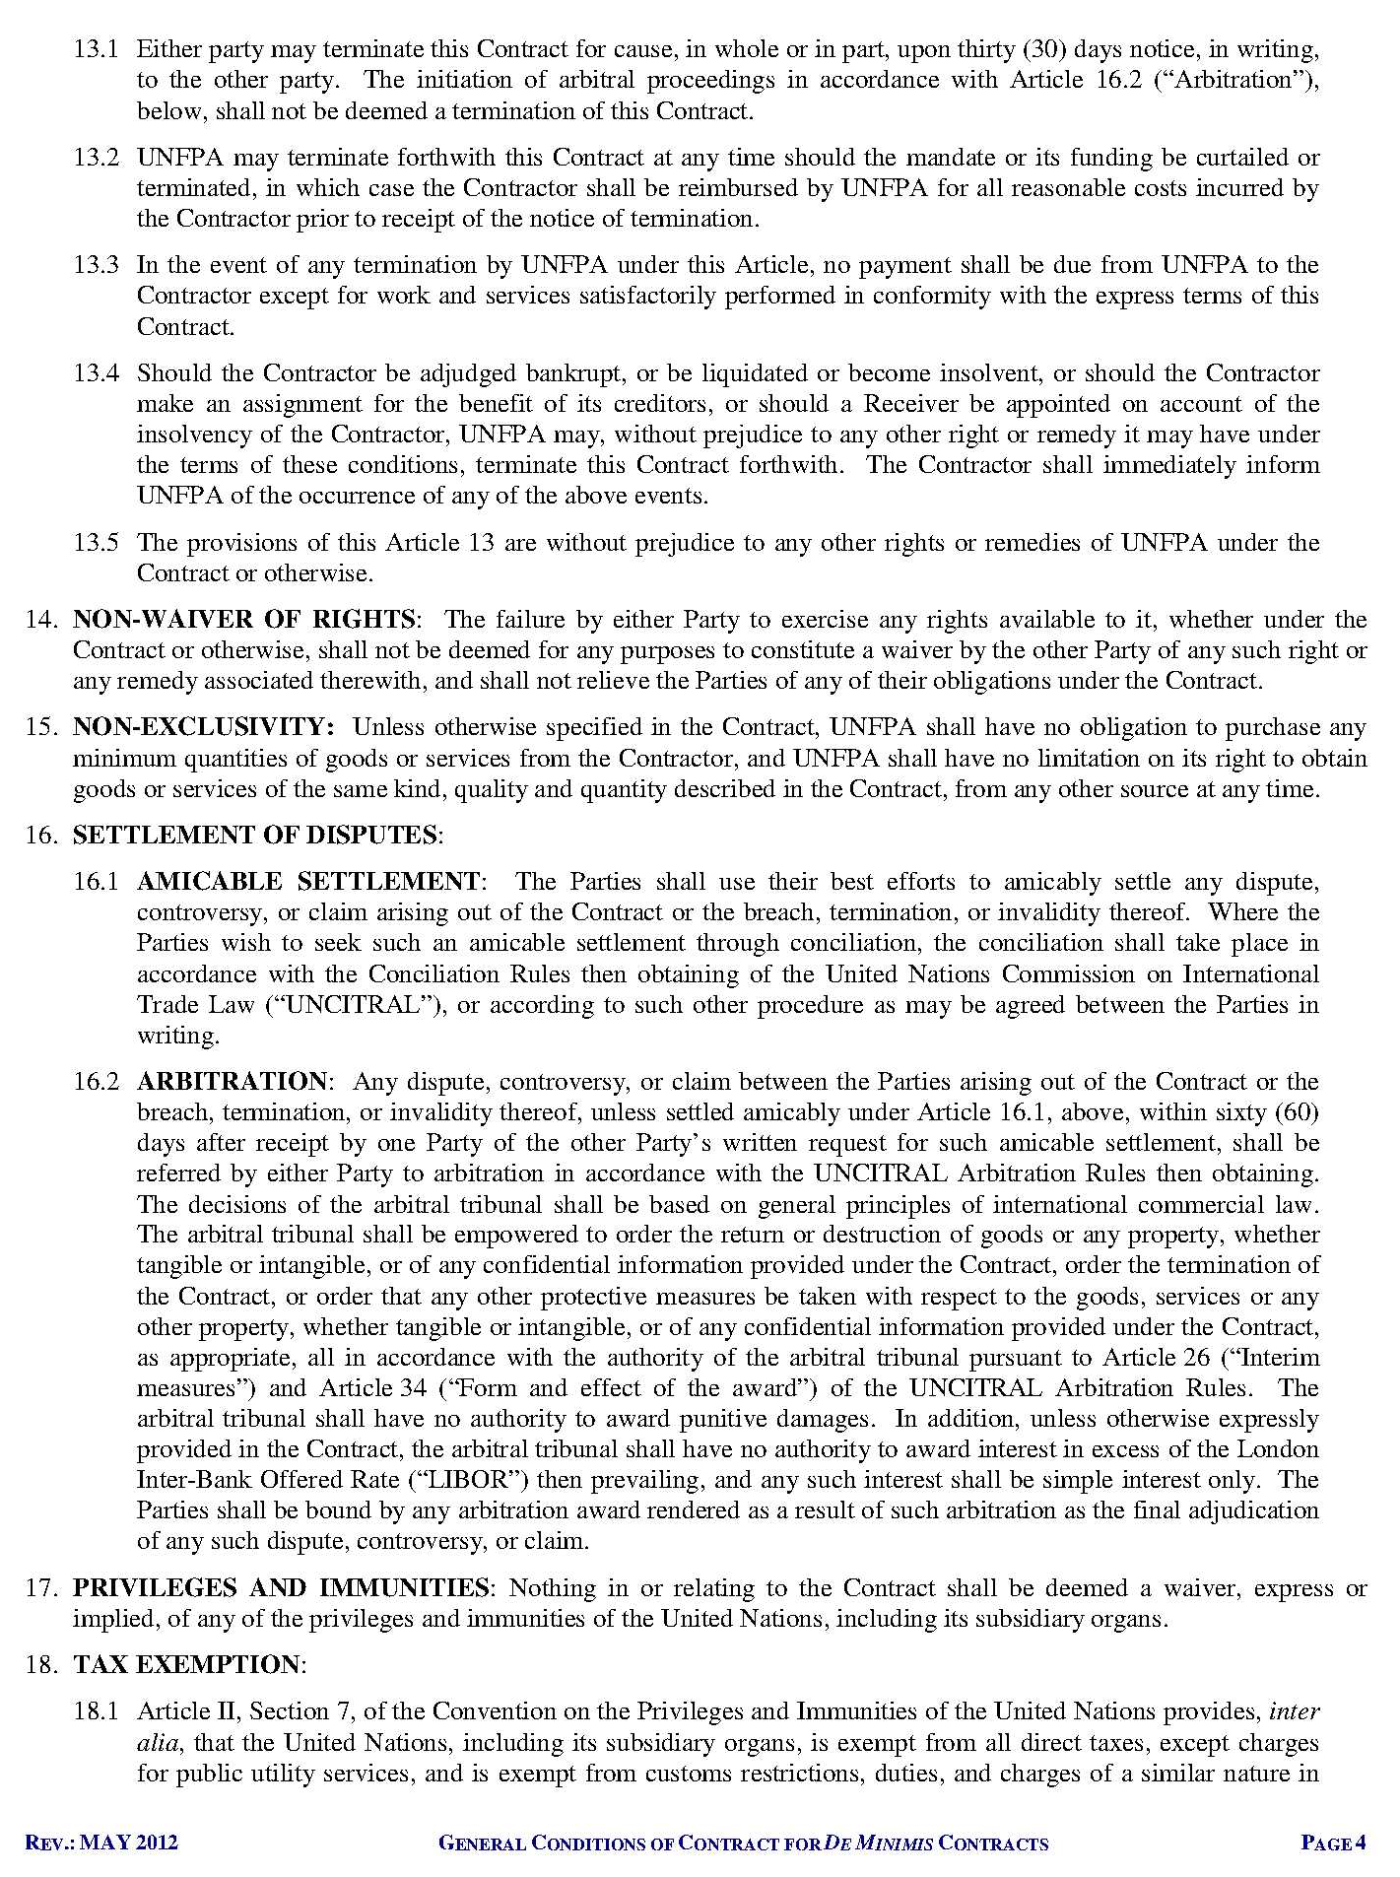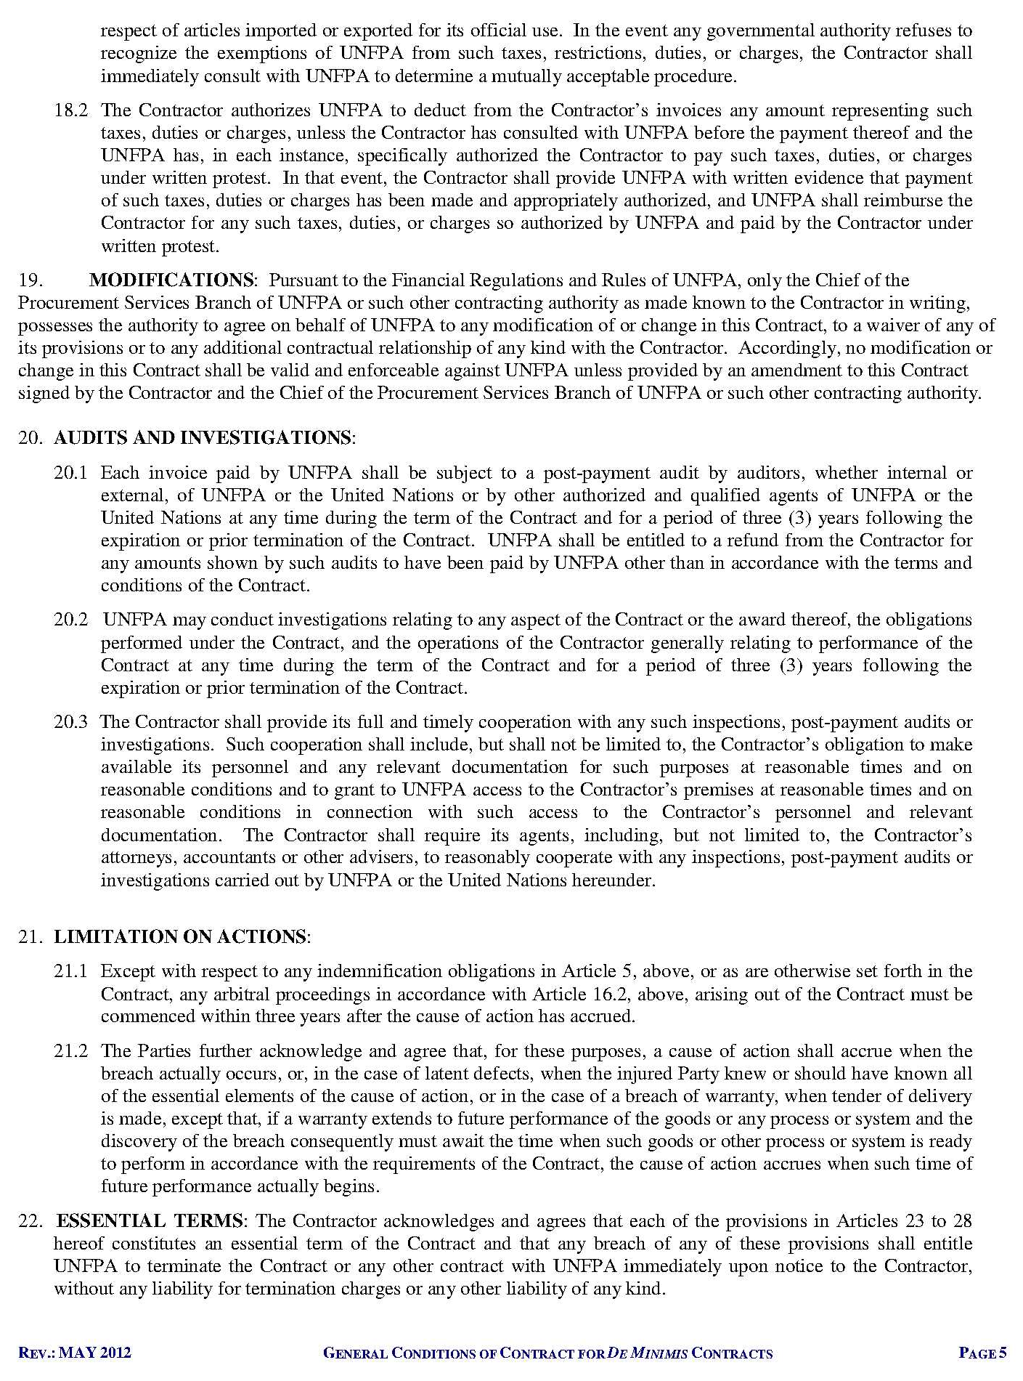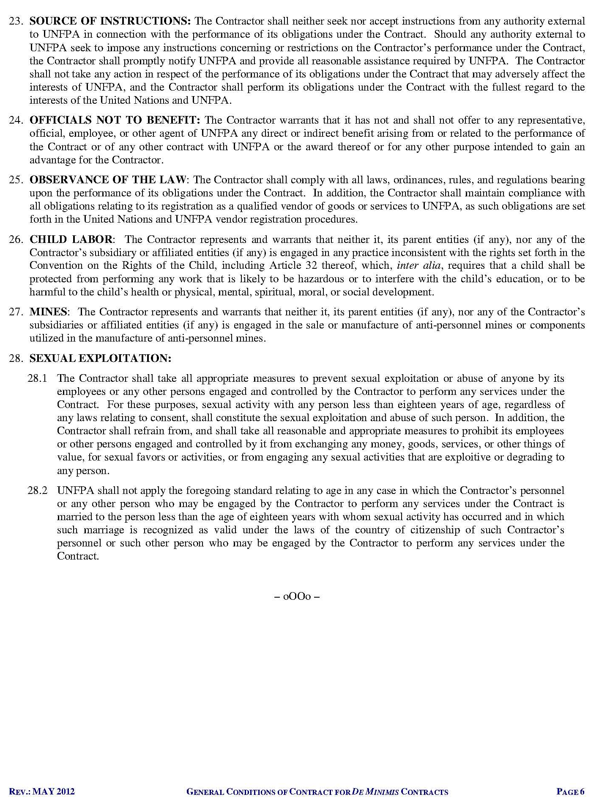

MoWA, 2016, Secondary analysis report of CDHS 2014

