Date: 4 February 2021

REQUEST FOR QUOTATION
RFQ Nº UNFPA/KHM/RFQ/21/002

Dear Sir/Madam,

UNFPA hereby solicits a quotation for the following service:

“Establishing a Web-based E-learning Platform for Sexual
and Reproductive Health and Rights (SRHR)”.

This Request for Quotation is open to all legally-constituted companies that can provide the requested services and have legal capacity to deliver in the country, or through an authorized representative.

I. About UNFPA
UNFPA, the United Nations Population Fund (UNFPA), is an international development agency that works to deliver a world where every pregnancy is wanted, every child birth is safe and every young person’s potential is fulfilled.

UNFPA is the lead UN agency that expands the possibilities for women and young people to lead healthy sexual and reproductive lives. To read more about UNFPA, please go to: UNFPA about us

II. Service Requirements/Terms of Reference (ToR)

1. Background information

As part of COVID-19 Pandemic UNFPA Global Response Plan, the UNFPA response involves a 3 pronged approach for sexual, reproductive, and maternity (SRMH) care, services, and information: 1) Protect SRMH care providers and SRMH workforce, 2) Provide safe, effective and integrated SRMH care, services and information to women, and 3) Maintain and protect integrated health systems.

There is evidence from the regional and global documents that there is an increased concern over the high risk of COVID-19 infection as a result of direct contact with women during providing and receiving SRMH care, services, and information such as Family Planning (FP), Antenatal Care (ANC), Childbirth, Emergency Obstetric and Newborn Care (EmONC), and Postnatal Care (PNC). The global guidance on Continuing essential Sexual, Reproductive, Maternal, Neonatal, Child and Adolescent Health services during COVID-19 pandemic by WHO, UNFPA and UNICEF also put forward a proposition to the national government to provide training and communication through digital health platform to prevent the infection of COVID-19.

Cambodia has made much progress and demonstrated high-level commitment to ensuring women’s rights are placed front and centre of its development journey. To achieve that, a health system’s resilience is vital to build and ensure it is well equipped to respond to the needs of women at times of epidemics like COVID-19. This also includes training midwives on an alternative delivery of integrated SRMH services and information such as advice on family planning, remote contact of antenatal care, and postnatal care through innovative and sustainable learning platforms, especially during the public health emergency crisis.

UNFPA Cambodia in partnership with Clinton Health Initiative Alliance (CHAI) and Alive and Thrive (A&T) continue to support the Ministry of Health/National Maternal and Child Health Centre (NMCHC) and other relevant institutions, including midwives association and council to play a pivotal role as a training centre for SRMH services and information across the country. In addition to the current training support on SRMH programmes, including family planning and EmONC, UNFPA continues to support NMCHC/NRHP and other institutions to build an innovative and sustainable e-learning platform during this outbreak through creating a website and Learning Management System (LMS) known as MOODLE which contains a range of educational materials, including topics on COVID-19, maternity service, ANC, FP, reproductive health, Childbirth, PNC, VAW, AYFHS, and EmONC but not limited to other such as Comprehensive Sexuality Education (CSE).

2. Overall goal of the project
The MOODLE platform for SRHR and a website for NMCHC are designed to support health professionals, including midwives to fulfil their Professional Continuing Education (CPD) especially during and beyond the pandemic through the role of NMCHC/NRHP/CMA in partnership with the Health Professional Councils and Health Developing Partners.

3. Development objective(s)
The E-learning Programme are aimed at the following:
- Supporting NMCHC/NRHP/CMA to become an e-learning CPD provider for SRHR through designing MOODLE platform for Maternal and Child Health courses and a website for NMCHC;
- Give ongoing and flexible in-service training opportunity amid the pandemic and beyond;
- Enhancing wider coverage of in-service training programme among health professional especially midwives national wide;
4. Outputs / Deliverable(s)
Deliverable 1: Designing a website for NMCHC
Deliverable 2: Setting up of Moodle platform
Deliverable 3: Maintenance of the Moodle platform and Website

5. Activities
Deliverable 1: Designing a website for NMCHC
- Present a list of features and functionalities that the website should have and approved by the NMCHC;
- Procure and pay for server space and hosting with a hosting company for year 2021-2022 in the name of NMCHC;
- Demonstrate the platform at several points in the process – before, at the midpoint, and at the end – for approval;
- Preparing and designing the contents in consultation with NMCHC, including:
- Upload all contents into websites;
- Communicate with NMCHC to download materials and information;
- Training NMCHC IT staff on maintenance and management of contents, including coding

Deliverable 2: Setting up of MOODLE platform
To achieve the deliverable 2, the following activities will be carried out:

Activity 1: Installation of the Moodle platform
Under the guidance of the Committee for E-learning, the successful firm/institution will carry out the following activities:
- Present a work-plan and timeline for approval by the NMCHC;
- Procure a Moodle license and request a domain name;
- Install, set up and run the Moodle platform;
- Procure and pay for server space and hosting through the Moodle to support more users for year 2021-2022 in the name of NMCHC;
- Demonstrate the platform at several points in the process – before, at the midpoint, and at the end – for approval;
- Provide a regular advanced back-up of the platform;
- Present a list of features and functionalities that the platform provides and approved by the NMCHC

Activity 2: Uploading learning materials (around 10 topics) to the Moodle platform
Technical committee under NMCHC is responsible for the development and endorsement of relevant topics to be uploaded into the Moodle platform. The task required to be performed by the software developer are:
- Support the NMCHC with preparing and uploading the contents, including:
- Adapt existing course contents from other platforms such as App and website to the Moodle;
- Upload all course contents into courses, including video, quizzes, text, and resource pages;
- Communicate with partners and content owners to download materials;
- Record voice-overs in Khmer to use with the videos if needed;
- Add sub-titles to videos;
- Re-formatting of videos, photos, document etc. to meet the Moodle platform requirements
- Create and present the users’ profile to see the progress of learning;
- Ensure quiz results and/or assignment can be easily exported for the purpose of marking and improvement;
- Build in a certificate with permitted CPD points into the courses

Activity 3: Testing and Modification
Upon the completion of contents uploading, the following deliverables will be made:
- Conduct all testing of the platform (back-end and front-end) with key users, followed by adjustments to address feedback raised

Activity 4: Trainings on the platform
During and after the completion of the uploading, the following activities will be carried out:
- Instructions/training on platform use and contents uploading for Content Creators (Taskforce) and key users;
- Design one 5-minute tutorial video and a training manual;
- Conduct the first orientation to key users, including Training Units of the Hospital and Cambodian Midwives Association Network/health centre on the process of learning platform (half-day)

Deliverable 3: Maintenance of the MOODLE and Website
Upon the completion of the above activities, this activity will be carried for the year 2022:
- Ongoing maintenance of the MOODLE and a website for the whole year 2022, including smooth operation and fixing bugs until the technical handover is completed by 31 December 2022
6. Specific requirements:
In order to complete above tasks in a satisfactory way the bidders are to comply with the following requirements:

- Supervision and quality assurance: The Contractor shall assign a supervisor or person of authority to co-ordinate all work performed for NMCHC. The supervisor shall conduct a quality assurance /check to insure compliance with the required work and confer at least once a month with NMCHC’s representative to ensure that the services requested have been performed to NMCHC’s satisfaction.
- Employees: The Contractor shall be exclusively and totally responsible for the fulfilment of all obligations of his/her employees assigned to the current assignment for NMCHC.

7. Inputs
Inputs given by the NMCHC
- Instruction for each course;
- All topics contents/learning materials

Inputs given by the Contractor
- IT staffs and team leader complete all required deliverables as outlined in these terms of reference.
- Breakdown of costs is provided in financial proposal in separate envelope.

8. Timing/Schedule
The contract is expected to be signed in March 2021. The duration of the contract is expected to be for a period of 9-month. Timeframe of the Completion of the Deliverables/outputs:
- Deliverable 1: Designing a website for NMCHC by 30 June 2021;
- Deliverable 2: Setting up of Moodle platform by 30 November 2021;
- Deliverable 3: Maintenance of the Moodle platform and Website by 30 December 2022.
- The contractor will provide a succinct progress 2021 report, including preliminary financial report, to UNFPA Cambodia by the 15 of December 2021, and
- The final report, including the preliminary financial expenditure report, maintenance and progress of the platform to UNFPA by the 30th of December 2022.

III. Questions
Questions or requests for further clarifications should be submitted in writing to the contact person below:

Name of contact person at UNFPA: | Mr. Livan Sophoan
Tel Nº: | +855 23 215519/216295
Fax Nº: | + 855 23 211339
Email address of contact person: | cambodia-procurement@unfpa.org

The deadline for submission of questions is Friday, February 15th2021 at 4 PM Phnom Penh time.. Questions will be answered in writing and shared with all parties as soon as possible after this deadline.

IV. Content of quotations
Quotations should be submitted in a single email whenever possible, depending on file size. Quotations must contain:

- Technical proposal, in response to the requirements outlined in the service requirements / TORs.
- Price quotation, to be submitted strictly in accordance with the price quotation form.

Both parts of the quotation must be signed by the bidding company’s relevant authority and submitted in PDF format.

V. Instructions for submission
Proposals should be prepared based on the guidelines set forth in Section III above, along with a properly filled out and signed price quotation form, and are to be sent by email to the contact person indicated below no later than Monday, February 28th 2021 at 4:00 PM Phnom Penh time..

Name of contact person at UNFPA: | Mr. Livan Sophoan
Email address of contact person: | cambodia-procurement@unfpa.org

Please note the following guidelines for electronic submissions:
- The following reference must be included in the email subject line: RFQ Nº UNFPA/KHM/RFQ/21/002 - Establishing a Web-based E-learning platform for Sexual and Reproductive Health and Rights (SRHR). Proposals, including both technical and financial proposals, that do not contain the correct email subject line may be overlooked by the procurement officer and therefore not considered.
- The total email size may not exceed 20 MB (including email body, encoded attachments and headers). Where the technical details are in large electronic files, it is recommended that these be sent separately before the deadline.
- Any quotation submitted will be regarded as an offer by the bidder and does not
constitute or imply the acceptance of any quotation by UNFPA. UNFPA is under no obligation to award a contract to any bidder as a result of this RFQ.

VI. Overview of Evaluation Process
Quotations will be evaluated based on the technical proposal and the total cost of the services (price quote).

The evaluation will be carried out in a two-step process by an ad-hoc evaluation panel. Technical proposals will be evaluated for technical compliance prior to the comparison of price quotes.

VII. Award Criteria
In case of a satisfactory result from the evaluation process, UNFPA intends to award an Agreement/Purchase Order with duration of nine (9) months to the Bidder(s) that obtain the lowest-priced technically acceptable offer.

VIII. Right to Vary Requirements at Time of Award
UNFPA reserves the right at the time of award of contract to increase or decrease, by up to 20%, the volume of services specified in this RFQ without any change in unit prices or other terms and conditions.

IX. Payment Terms
UNFPA payment terms are net 30 days upon receipt of invoice and delivery/acceptance of the milestone deliverables linked to payment as specified in the contract.

X. Fraud and Corruption
UNFPA is committed to preventing, identifying, and addressing all acts of fraud against UNFPA, as well as against third parties involved in UNFPA activities. UNFPA’s Policy regarding fraud and corruption is available here: Fraud Policy. Submission of a proposal implies that the Bidder is aware of this policy.

Suppliers, their subsidiaries, agents, intermediaries and principals must cooperate with the UNFPA Office of Audit and Investigations Services as well as with any other oversight entity authorized by the Executive Director and with the UNFPA Ethics Advisor as and when required. Such cooperation shall include, but not be limited to, the following: access to all employees, representatives agents and assignees of the vendor; as well as production of all documents requested, including financial records. Failure to fully cooperate with investigations will be considered sufficient grounds to allow UNFPA to repudiate and terminate the Agreement, and to debar and remove the supplier from UNFPA's list of registered suppliers.

A confidential Anti-Fraud Hotline is available to any Bidder to report suspicious fraudulent activities at UNFPA Investigation Hotline.

Zero Tolerance
UNFPA has adopted a zero-tolerance policy on gifts and hospitality. Suppliers are therefore requested not to send gifts or offer hospitality to UNFPA personnel. Further details on this policy are available here: Zero Tolerance Policy.

XI. RFQ Protest
Bidder(s) perceiving that they have been unjustly or unfairly treated in connection with a solicitation, evaluation, or award of a contract may submit a complaint to the UNFPA Head of the Business Unit Mr. Daniel Alemu, Representative, a.i at dalemu@unfpa.org. Should the supplier be unsatisfied with the reply provided by the UNFPA Head of the Business Unit, the supplier may contact the Chief, Procurement Services Branch at procurement@unfpa.org.

XII. Disclaimer
Should any of the links in this RFQ document be unavailable or inaccessible for any reason, bidders can contact the Procurement Officer in charge of the procurement to request for them to share a PDF version of such document(s).

PRICE Quotation Form

Name of Bidder:
Date of the quotation: | Click here to enter a date.
Request for quotation Nº: | UNFPA/KHM/RFQ/21/002
Currency of quotation: | USD
Delivery charges based on the following 2010 Incoterm: | Choose an item.
Validity of quotation:
(The quotation shall be valid for a period of at least 3 months after the submission deadline.)

- Quoted rates must be exclusive of all taxes, since UNFPA is exempt from taxes.

Example Price Schedule below: [Delete after properly completing the Price Schedule, also develop excel version]

Item | Description | Number & Description of Staff by Level | Hourly Rate | Hours to be Committed | Total
- Professional Fees
Total Professional Fees |  |  |  |  | $$
- Out-of-Pocket expenses
Total Out of Pocket Expenses |  |  |  |  | $$
Total Contract Price  (Professional Fees + Out of Pocket Expenses) |  |  |  |  | $$

Vendor’s Comments:

I hereby certify that the company mentioned above, which I am duly authorized to sign for, has reviewed RFQ UNFPA/KHM/RFQ/21/002 including all annexes, amendments to the RFQ document (if applicable) and the responses provided by UNFPA on clarification questions from the prospective service providers. Further, the company accepts the General Conditions of Contract for UNFPA and we will abide by this quotation until it expires.
 | Click here to enter a date.
Name and title | Date and place

ANNEX I:
General Conditions of Contracts:
De Minimis Contracts

This Request for Quotation is subject to UNFPA’s General Conditions of Contract: De Minimis Contracts, which are available in: English, Spanish and French
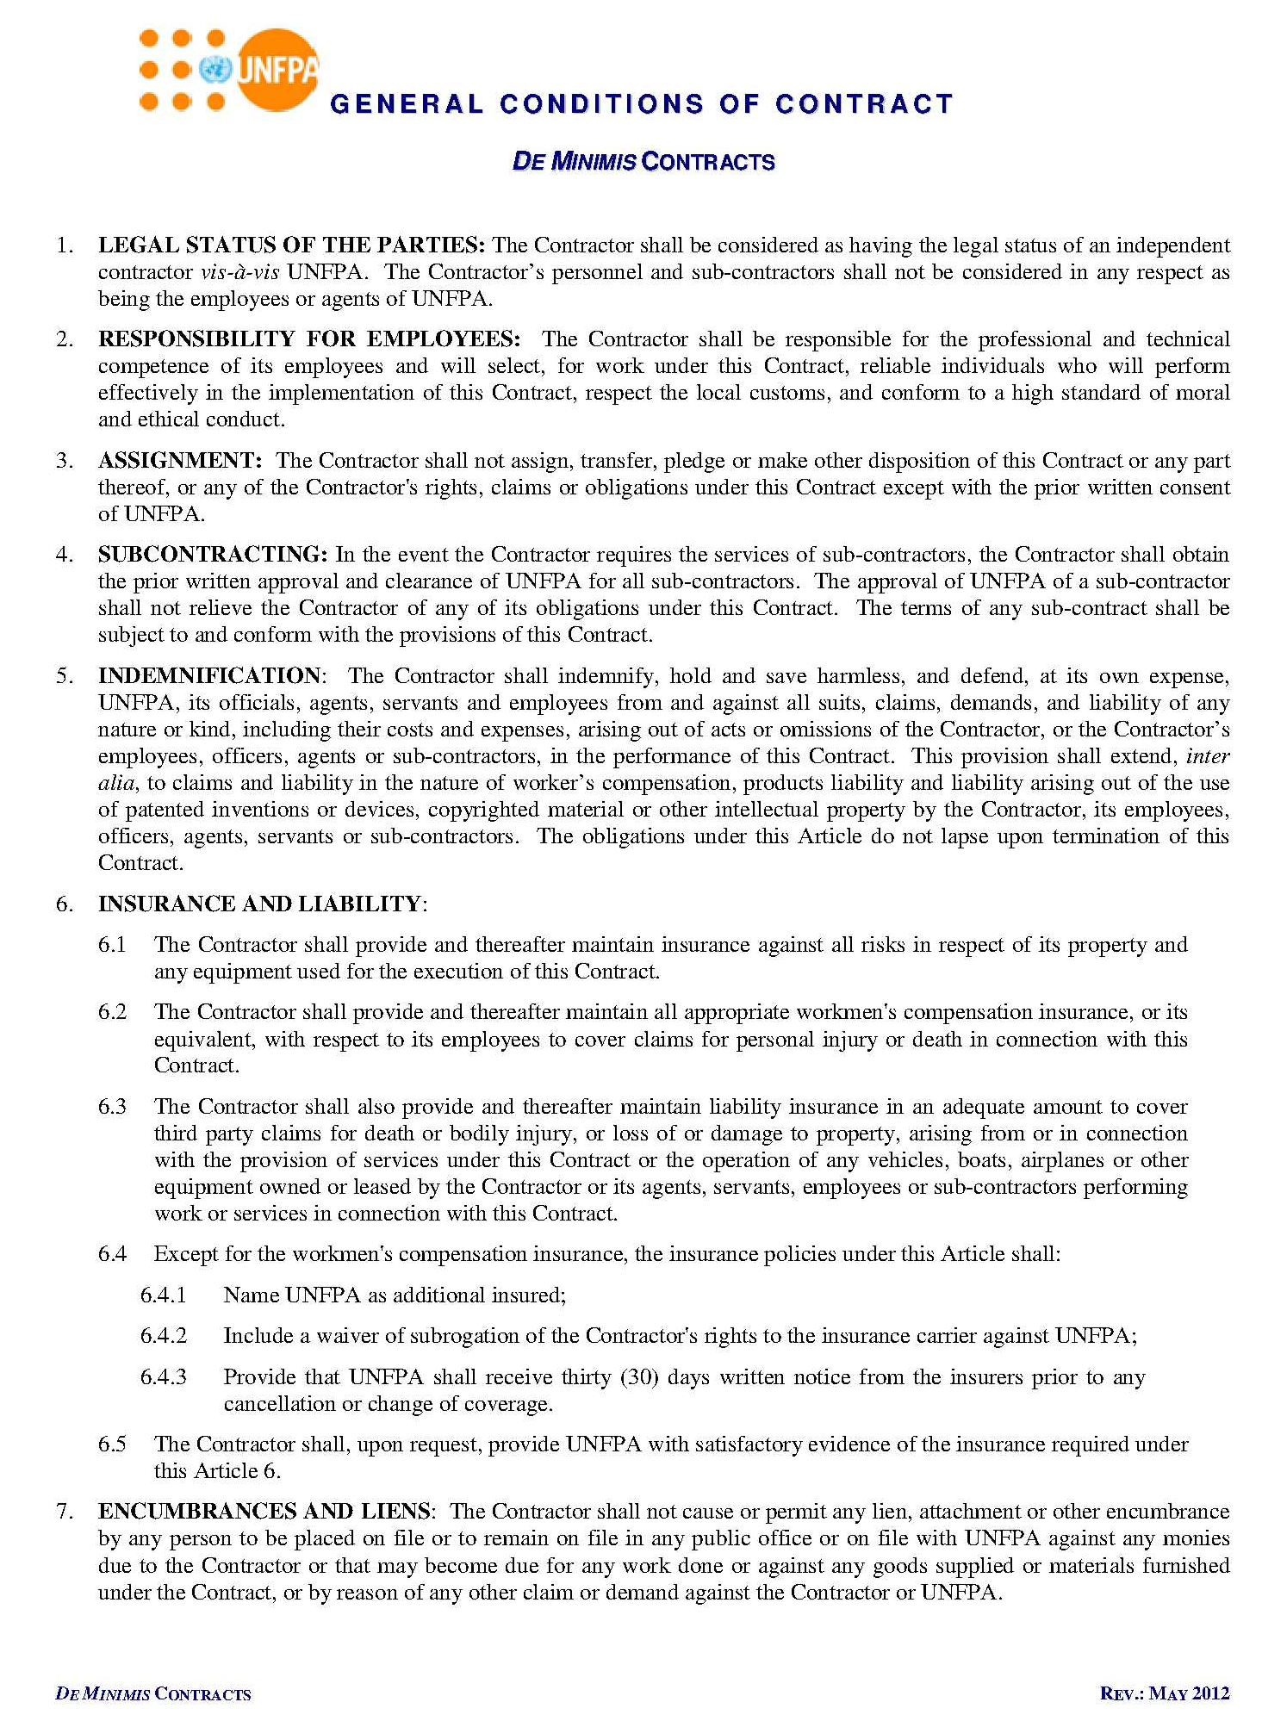
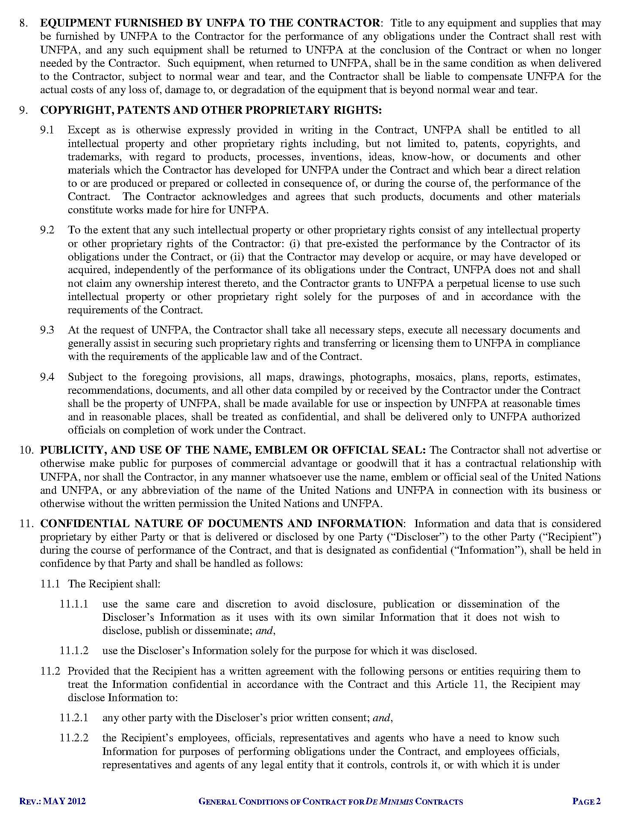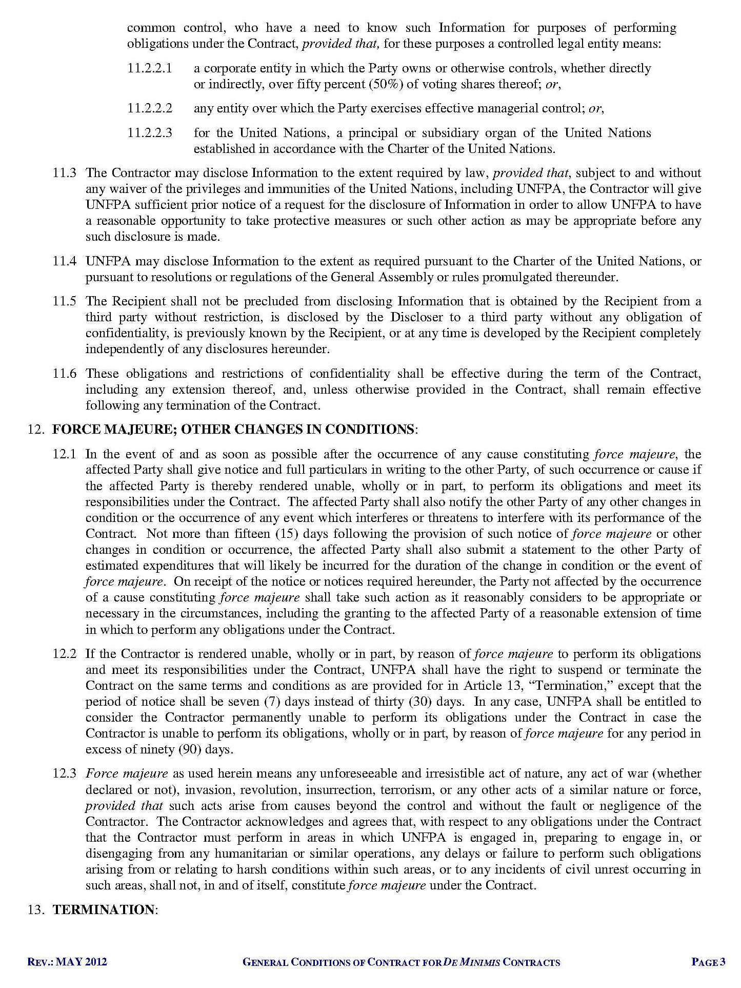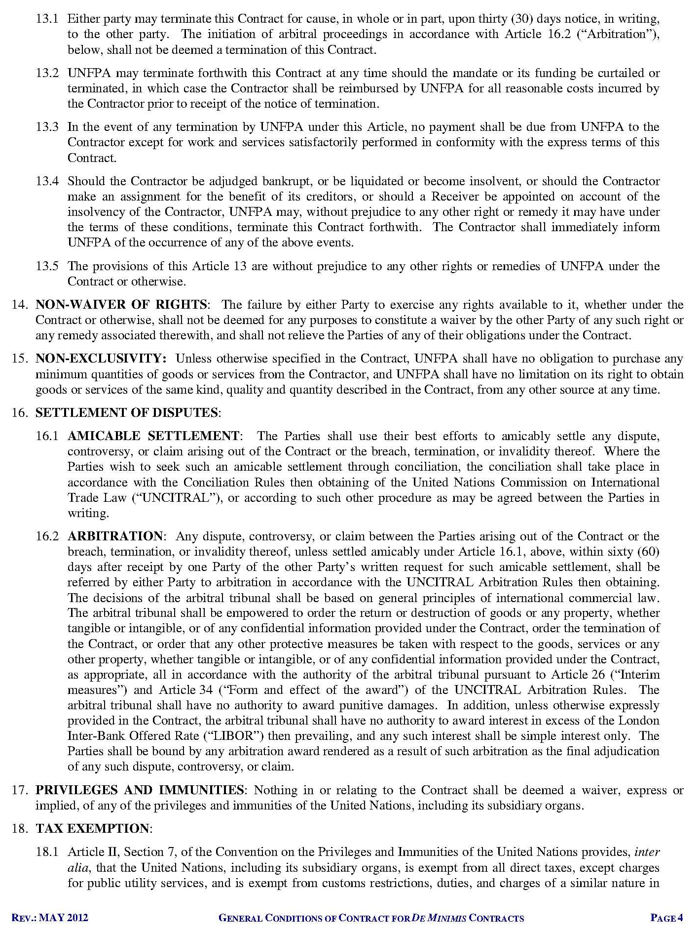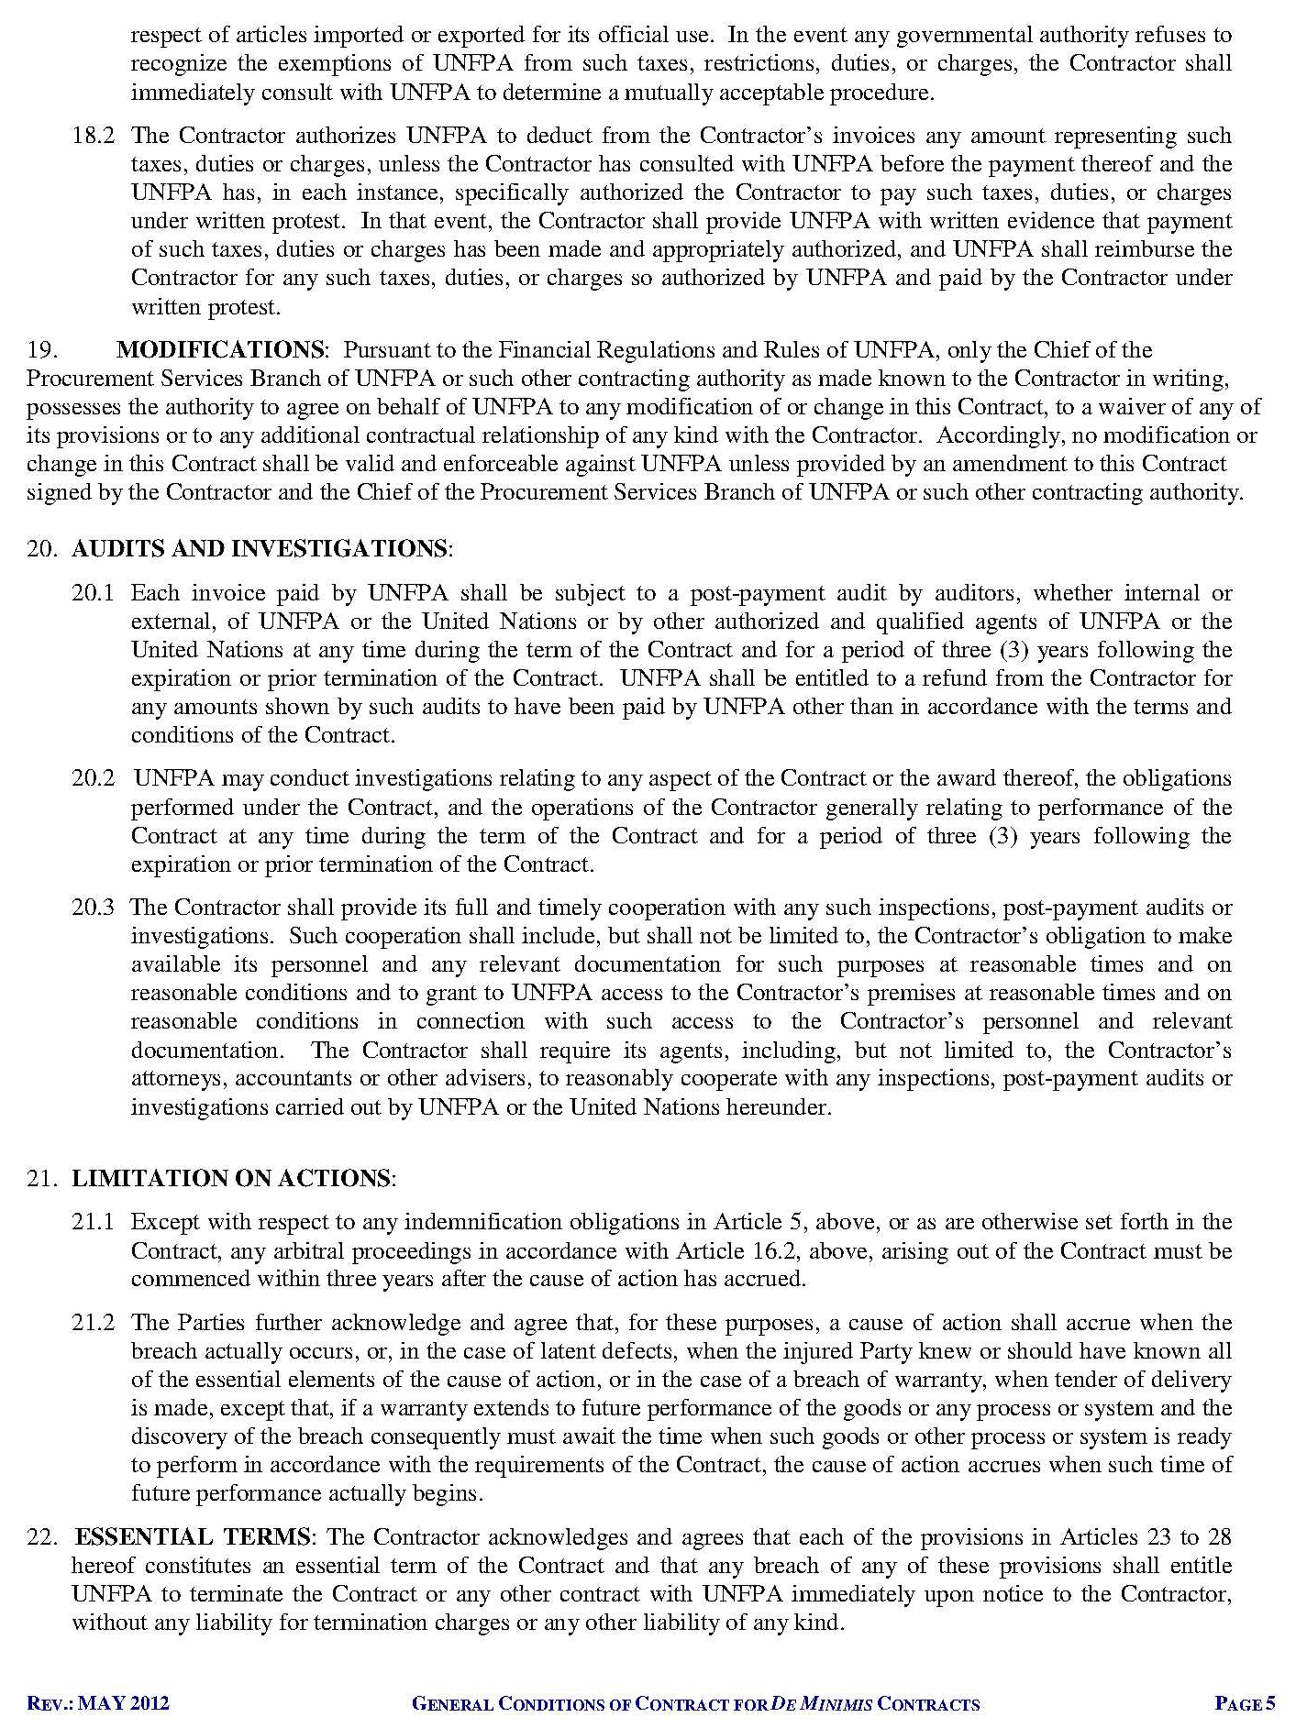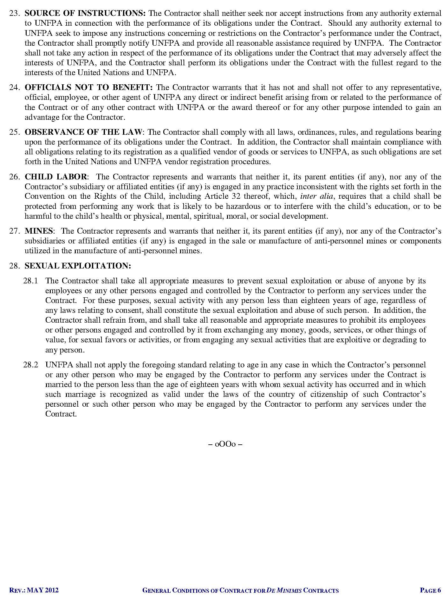

http://www.timeanddate.com/worldclock/city.html?n=69
http://www.timeanddate.com/worldclock/city.html?n=69

