Date: 1 June 2021

REQUEST FOR QUOTATION
RFQ Nº UNFPA/KHM/RFQ/21/004

Dear Sir/Madam,

UNFPA hereby solicits a quotation for the following service:

“Undertaking Analysis of Big Data on VAW and Mental Health in Cambodia”
UNFPA seeks a research firm/institution to conduct a “Undertaking Analysis of Big Data on VAW and Mental Health in Cambodia”. This Request for Quotation is open to all legally-constituted companies/institutions that can conduct this study within a proposed timeframe.

- About UNFPA

UNFPA, the United Nations Population Fund (UNFPA), is an international development agency that works to deliver a world where every pregnancy is wanted, every child birth is safe and every young person’s potential is fulfilled.

UNFPA is the lead UN agency that expands the possibilities for women and young people to lead healthy sexual and reproductive lives. To read more about UNFPA, please go to: UNFPA about us

Service Requirements/Terms of Reference (ToR)
BACKGROUND

Intimate Partner Violence (IPV) is a signiﬁcant issue for a large number of women around the globe. As per the UN reports, 35% of women around the world have experienced some sort of physical or sexual violence while some 75% of women face physical and sexual hostility. In Cambodia, 1 in 5 women aged 15-64 who have ever been in a relationship, reported to have experienced physical and/or sexual violence by an intimate partner in their lifetime. The National Survey on “Women’s Health and Life’s Experiences in Cambodia” conducted by WHO in Cambodia in 2015 found similar prevalence. The recent anecdotal evidence of service providers shows that Cambodia has also seen an increase in gender-based violence. A youth situation analysis conducted in 2020 indicates that around a tenth (12%) of youth experienced a form of abuse in the past 12 months- 14% males and 10% females reported that they were physically abused domestically. Among the young respondents aged 10-14, UNFPA’s quick assessment report in 2020 and Future Forum’s study found that GBV cases do not increase during COVID-19 in Cambodia.

In the meantime, the movement restrictions, lockdown and curfew to control the pandemic have impacted the people economically and mentally. A number of studies conducted in 2020 found that the pandemic has affected the mental health of young and old people alike. UNFPA’s rapid assessment “Barriers in access to sexual and reproductive health services among youth and women in Cambodia” in three provinces in Cambodia found that 38% of the respondents reported that their mental health became worse in 2020 in comparison with 2019. A youth situation analysis (aged 10-24) undertaken in 11 provinces in Cambodia in 2020 shows that among the young respondents aged 10-14, about 11% said that they had been very anxious or depressed and around 14% of them have experienced it when COVID-19 happened. The migrant workers returning to Cambodia in early 2020 reported that their mental health (40.9%) became worse during the pandemic. The study with Cambodian Migrant Workers (1,200 workers) in Thailand indicates that 57.7% of the respondents stated that they experienced stress.

OBJECTIVES OF ASSESSMENT

- To undertake analysis on VAW by intimate partners in Cambodia using big data (social media, internet search engines, TV/radio broadcast data, podcast data, digital newspaper etc.)
- To undertake analysis on mental health in Cambodia using big data
- the link between mental health problems and VAW using big data
- To help fill evidence gaps on mental health problems and VAW by intimate partners
- To support programme and policy formulation to address VAW by intimate partners and mental health problems in Cambodia, especially during the pandemic

SCOPE OF WORK

The company/institution will perform the following indicative tasks

- Conduct literature review;
- Develop research protocol including methodology (i.e. tools, sampling methods etc.) research timeframe etc.;
- Revise the research protocol based on the inputs and comments;
- Collect and analyse data based on the themes agreed in the proposal;
- Draft and share research report with UNFPA and its partners for comments and inputs;
- Integrate inputs from UNFPA and its partners and finalise the report with recommendations for programming interventions and policy formulation.

EXPECTED KEY DELIVERABLES

The research company/institution will work closely with UNFPA and its partners produce the following deliverables in a quality, consultative and timely manner:

- Literature review on VAW and mental health problems and their connection conducted;
- Research proposal revised based on the inputs and comments from UNFPA and partners;
- Research tools, particularly questionnaire, developed and revised;
- Data collected and analysed;
- Draft report prepared and presented;
- The report finalized by integrating the inputs and comments along with recommendations for programming interventions and policy formulation.

Qualifications and requirements

- Proven record of experience in conducting analysis on big data
- Evidence of familiarity with existing knowledge/research on VAW and mental health problems. At least two sample reports of past studies SHALL be sent along with the proposal and
- Proposed methods are appropriate and feasible for the study;
- Strengths, capacity and expertise of the research team to successfully implement the study within a tight timeframe;
- Ethical issues have been considered.
- Legally established firm/institution;
- Updated CVs of the proposed team members, including that of the team leader;

- Questions
Questions or requests for further clarifications should be submitted in writing to the contact person below:

Name of contact person at UNFPA: | Ms. Sokroeun Aing, Programme Analyst, Gender/R&H
Tel Nº: | +855 23 215519-118
Fax Nº: | +85512 575 161
Email address of contact person: | aing@unfpa.org

The deadline for submission of questions is 20 June 2021 by 17:00 p.m. Phnom Penh time. Questions will be answered in writing and shared with parties as soon as possible after this deadline.

- Content of quotations
Quotations should be submitted in a single email whenever possible, depending on file size. Quotations must contain:

- A detailed technical research proposal and two sample reports of past studies, in response to the requirements outlined in the service requirements / TORs.

- Price quotation, to be submitted strictly in accordance with the price quotation form. The total budget for this study does not exceed US$25,000.

Both parts of the quotation must be signed by the bidding company’s relevant authority and submitted in PDF format.

- Instructions for submission
Proposals should be prepared based on the guidelines set forth in Sections above, along with a properly filled out and signed price quotation form, and are to be sent by email to the contact person indicated below no later than: Sunday, 20 June 2021 at 17:00 p.m. Phnom Penh Time.

Name of contact person at UNFPA: | Mr. Sophoan Livan
Email address of contact person: | Cambodia Procurement <cambodia-procurement@unfpa.org>

Please note the following guidelines for electronic submissions:

- The following reference must be included in the email subject line: RFQ Nº UNFPA/KHM/RFQ/21/004 “Undertaking Analysis of Big Data on VAW and Mental in Cambodia” Proposals, including both technical and financial proposals, that do not contain the correct email subject line may be overlooked by the procurement officer and therefore not considered.

- The total email size may not exceed 20 MB (including email body, encoded attachments and headers). Where the technical details are in large electronic files, it is recommended that these be sent separately before the deadline.

- Any quotation submitted will be regarded as an offer by the bidder and does not
constitute or imply the acceptance of any quotation by UNFPA. UNFPA is under no obligation to award a contract to any bidder as a result of this RFQ.

- Overview of Evaluation Process
Quotations will be evaluated based on the technical proposal and the total cost of the services (price quote).

The evaluation will be carried out in a two-step process by an ad-hoc evaluation panel. Technical proposals will be evaluated for technical compliance prior to the comparison of price quotes.

- Award Criteria
In case of a satisfactory result from the evaluation process, UNFPA intends to award a Professional Service Contract on a fixed-cost basis or ceiling prices basis with duration of two (02) months to the Bidder(s) that obtain the lowest-priced technically acceptable offer.

- Right to Vary Requirements at Time of Award
UNFPA reserves the right at the time of award of contract to increase or decrease, by up to 20%, the volume of services specified in this RFQ without any change in unit prices or other terms and conditions.

- Payment Terms
UNFPA payment terms are net 30 days upon receipt of invoice and delivery/acceptance of the milestone deliverables linked to payment as specified in the contract.

- Fraud and Corruption
UNFPA is committed to preventing, identifying, and addressing all acts of fraud against UNFPA, as well as against third parties involved in UNFPA activities. UNFPA’s Policy regarding fraud and corruption is available here: Fraud Policy. Submission of a proposal implies that the Bidder is aware of this policy.

Suppliers, their subsidiaries, agents, intermediaries and principals must cooperate with the UNFPA Office of Audit and Investigations Services as well as with any other oversight entity authorized by the Executive Director and with the UNFPA Ethics Advisor as and when required. Such cooperation shall include, but not be limited to, the following: access to all employees, representatives agents and assignees of the vendor; as well as production of all documents requested, including financial records. Failure to fully cooperate with investigations will be considered sufficient grounds to allow UNFPA to repudiate and terminate the Agreement, and to debar and remove the supplier from UNFPA's list of registered suppliers.

A confidential Anti-Fraud Hotline is available to any Bidder to report suspicious fraudulent activities at UNFPA Investigation Hotline.

- Zero Tolerance
UNFPA has adopted a zero-tolerance policy on gifts and hospitality. Suppliers are therefore requested not to send gifts or offer hospitality to UNFPA personnel. Further details on this policy are available here: Zero Tolerance Policy.

- RFQ Protest
Bidder(s) perceiving that they have been unjustly or unfairly treated in connection with a solicitation, evaluation, or award of a contract may submit a complaint to the UNFPA Head of the Business Unit, Mr. Daniel Alemu, Representative, a.i at dalemu@unfpa.org. Should the supplier be unsatisfied with the reply provided by the UNFPA Head of the Business Unit, the supplier may contact the Chief, Procurement Services Branch at procurement@unfpa.org.

- Disclaimer
Should any of the links in this RFQ document be unavailable or inaccessible for any reason, bidders can contact the Procurement Officer in charge of the procurement to request for them to share a PDF version of such document(s).

PRICE QUOTATION FORM

Name of Bidder:
Date of the quotation: | Click here to enter a date.
Request for quotation Nº: | UNFPA/KHM/RFQ/21/004
Currency of quotation: | USD
Delivery charges based on the following 2010 Incoterm: | Choose an item.
Validity of quotation:
(The quotation shall be valid for a period of at least 3 months after the submission deadline.)

- Quoted rates must be exclusive of all taxes, since UNFPA is exempt from taxes.

Item | Description | Number & Description of Staff by Level | Hourly Rate | Hours to be Committed | Total
- Professional Fees
Total Professional Fees |  |  |  |  | $$
- Out-of-Pocket expenses
Total Out of Pocket Expenses |  |  |  |  | $$
Total Contract Price  (Professional Fees + Out of Pocket Expenses) |  |  |  |  | $$
Vendor’s Comments:

I hereby certify that the company mentioned above, which I am duly authorized to sign for, has reviewed RFQ UNFPA/KHM/RFQ/? including all annexes, amendments to the RFQ document (if applicable) and the responses provided by UNFPA on clarification questions from the prospective service providers. Further, the company accepts the General Conditions of Contract for UNFPA and we will abide by this quotation until it expires.
 | Click here to enter a date.
Name and title | Date and place

ANNEX I:
General Conditions of Contracts:
De Minimis Contracts

This Request for Quotation is subject to UNFPA’s General Conditions of Contract: De Minimis Contracts, which are available in: English, Spanish and French

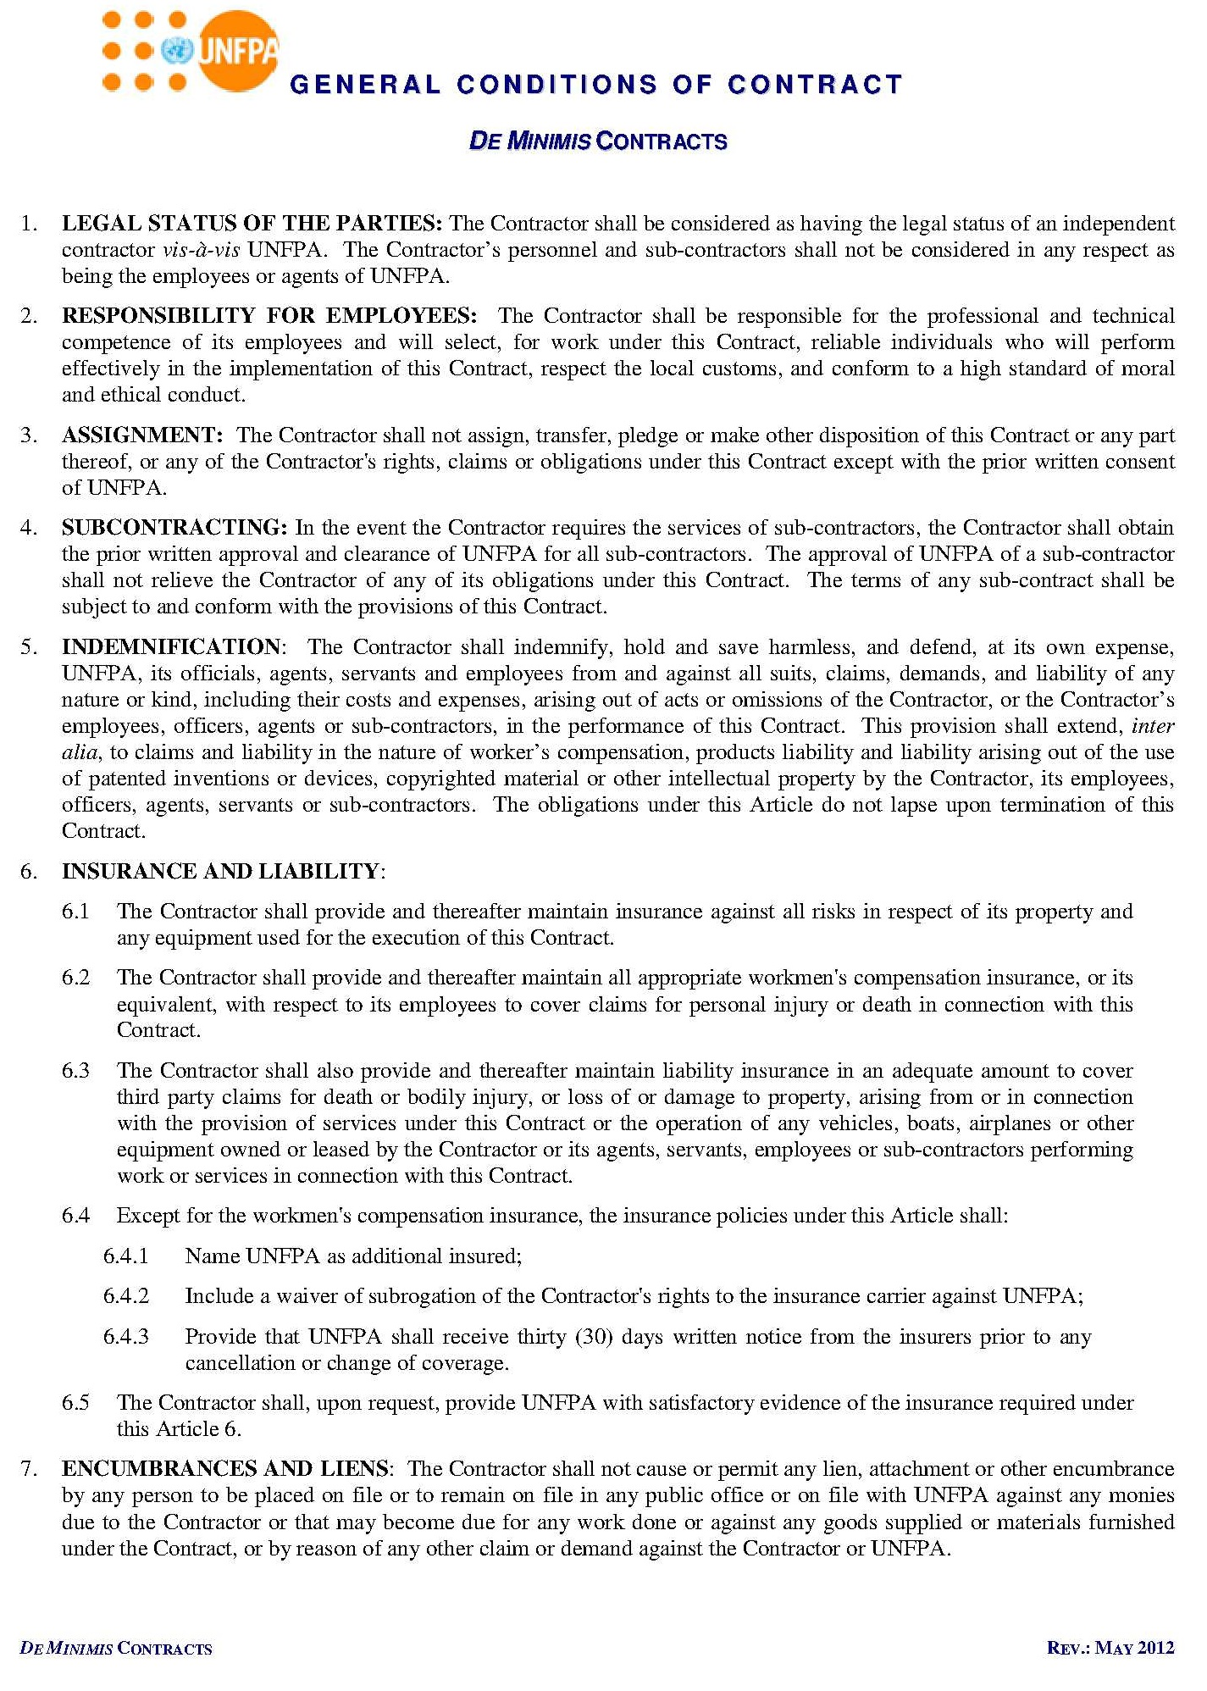
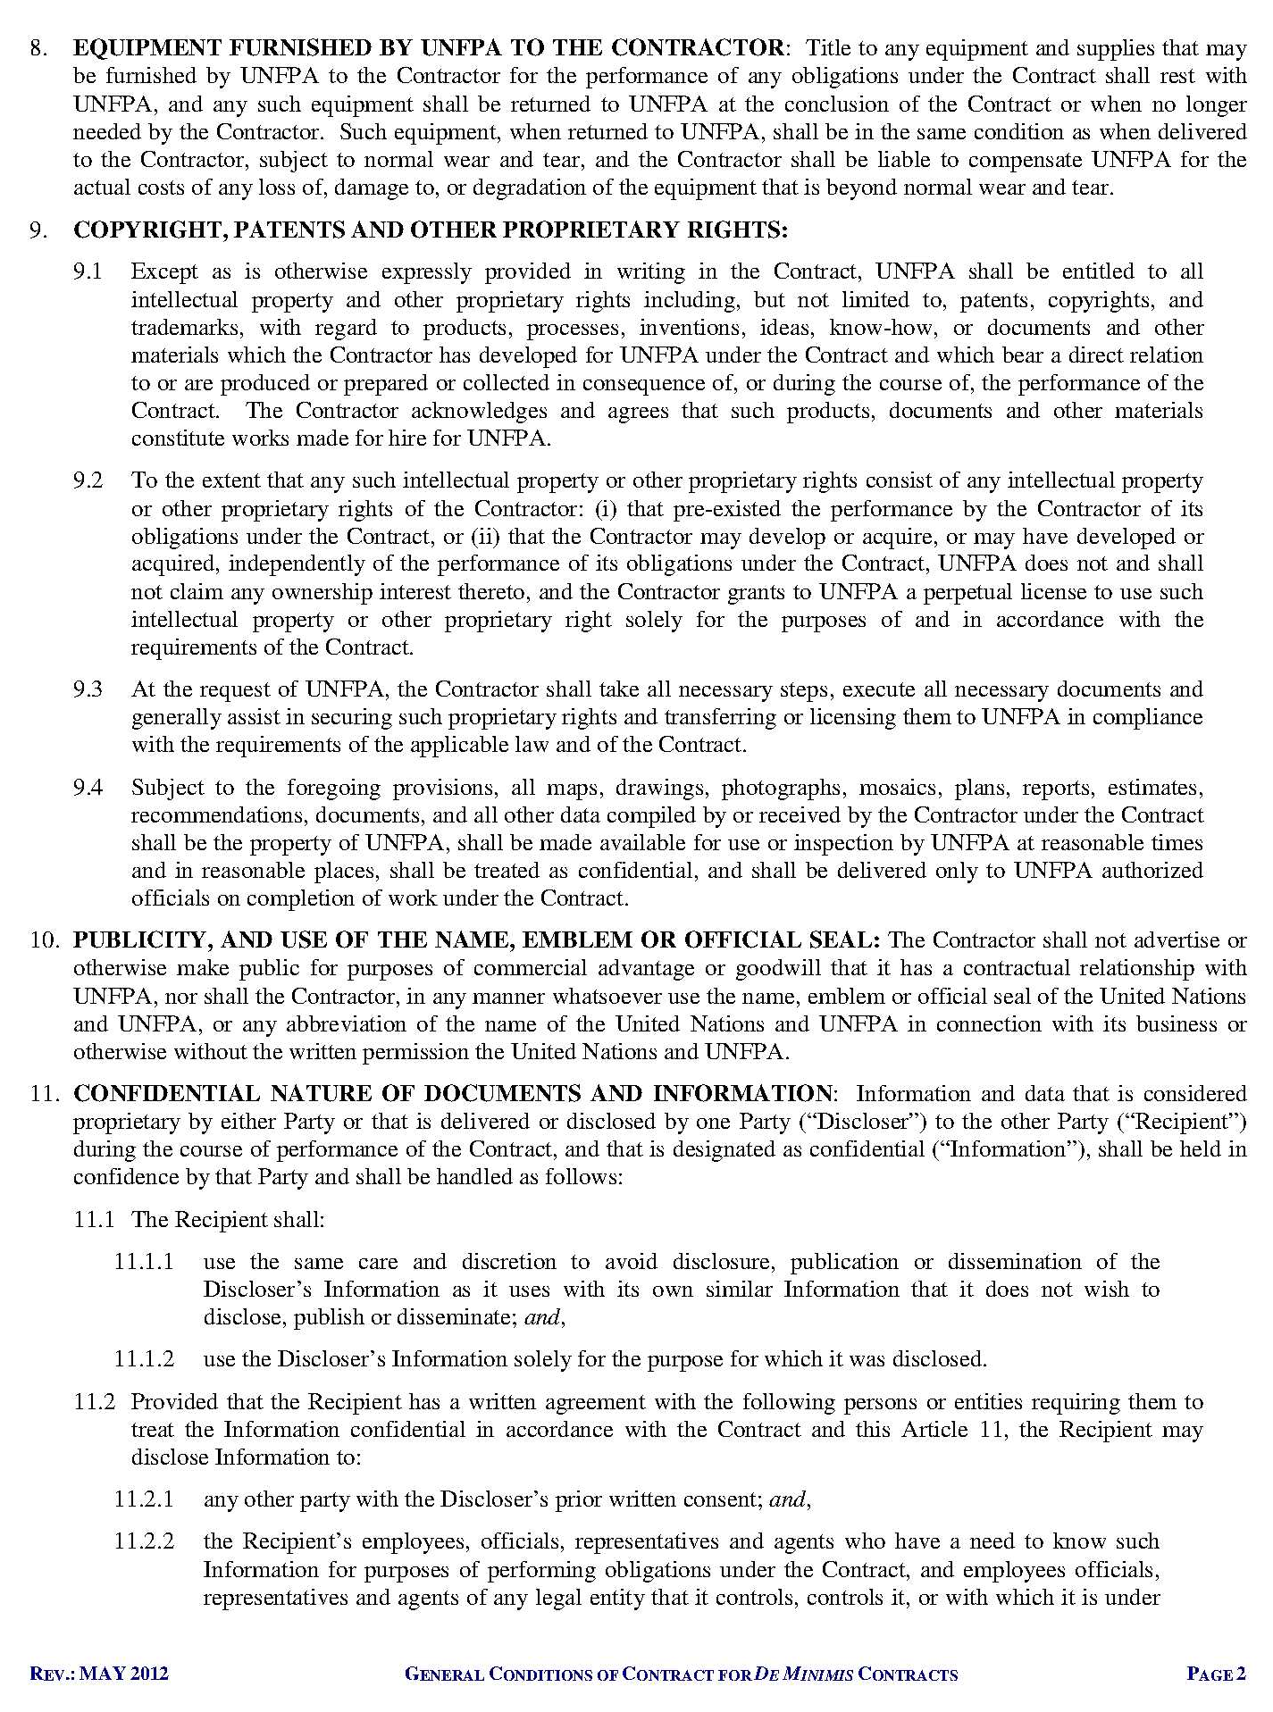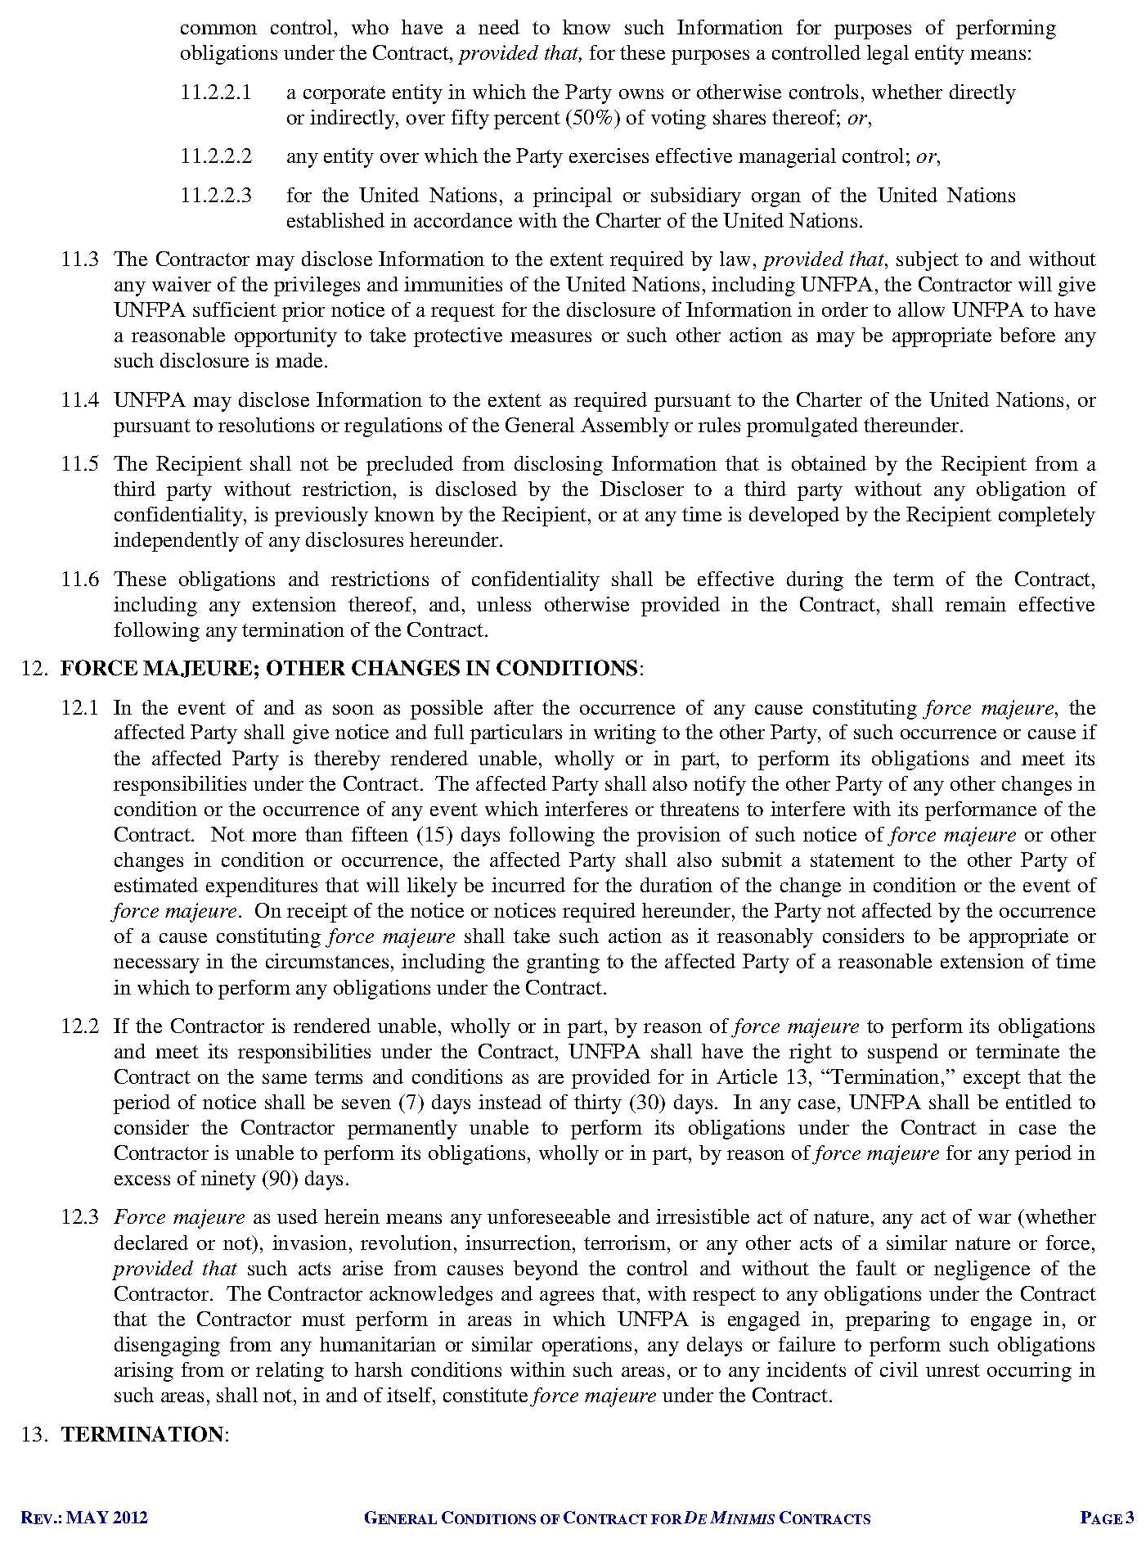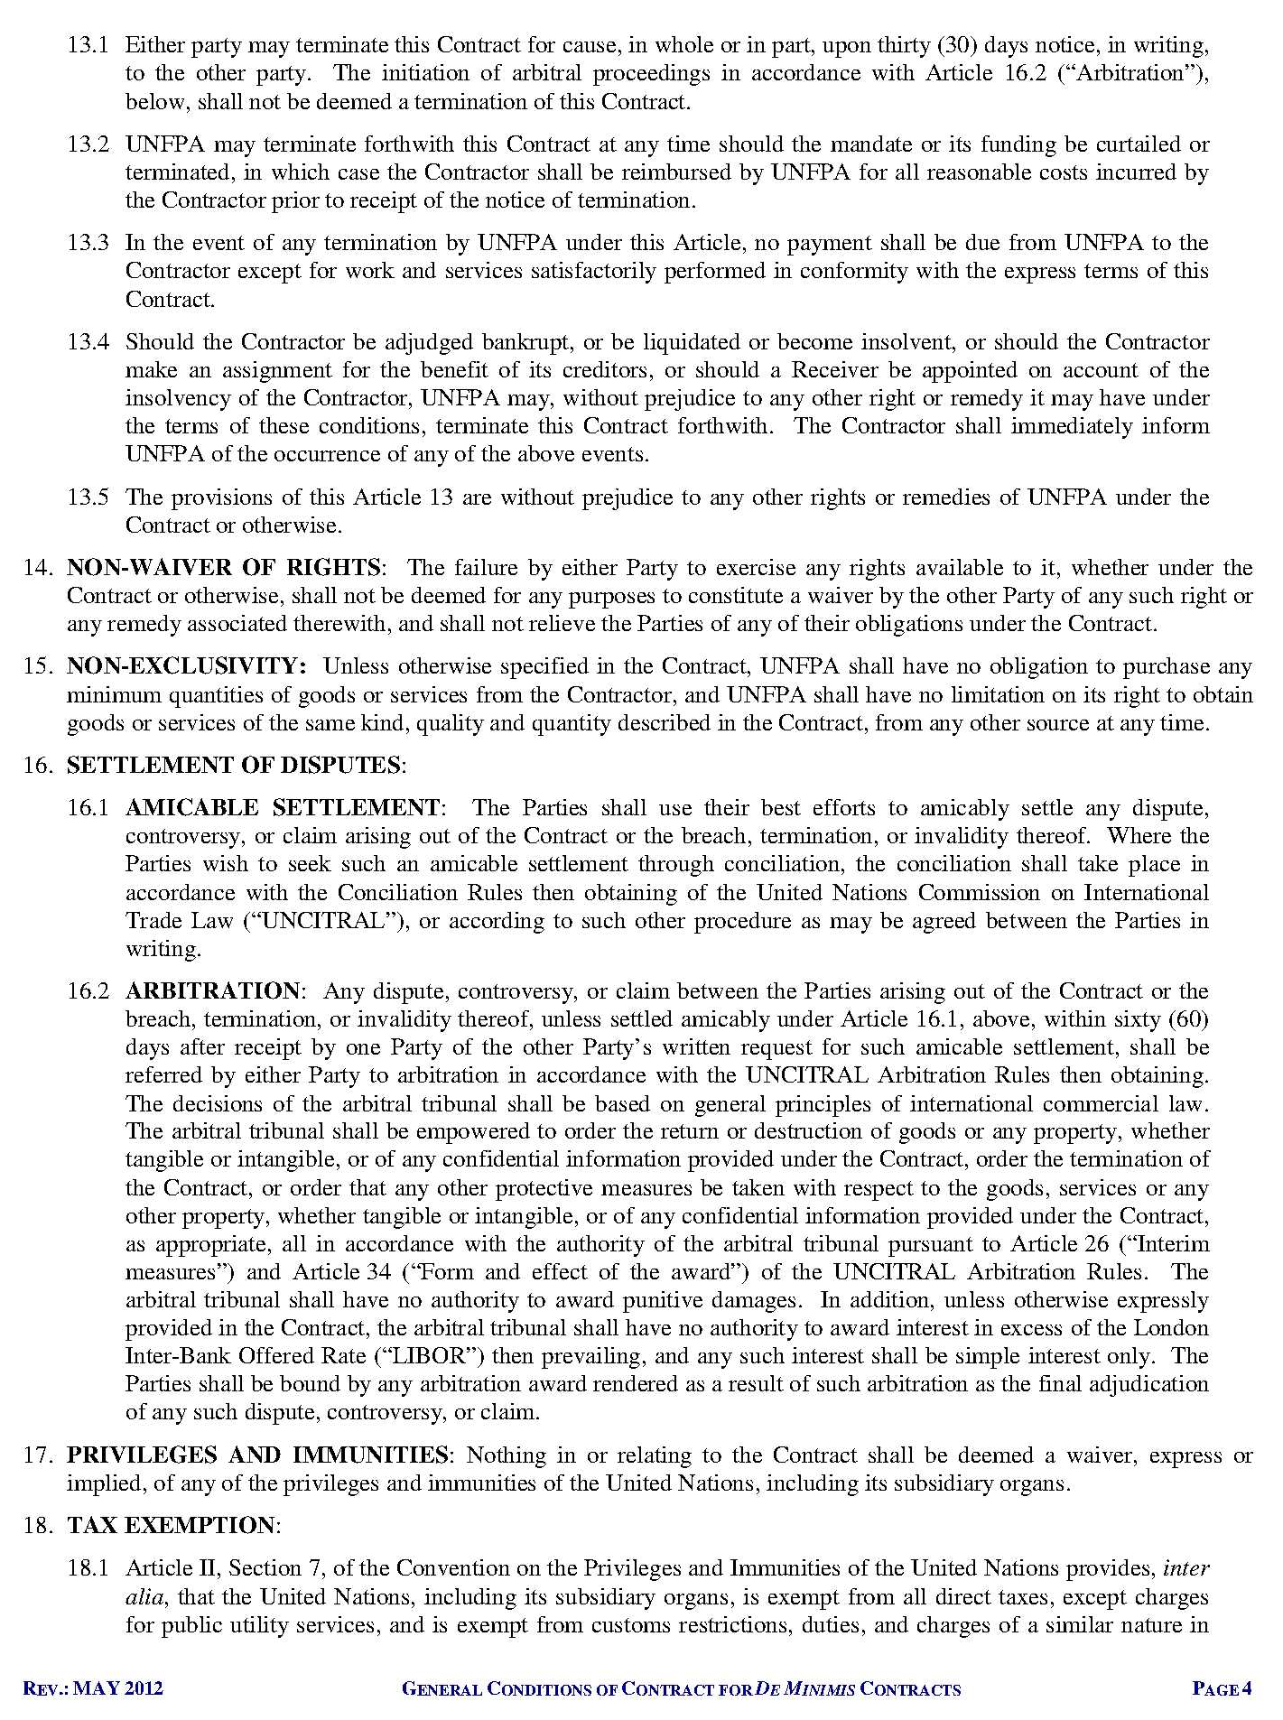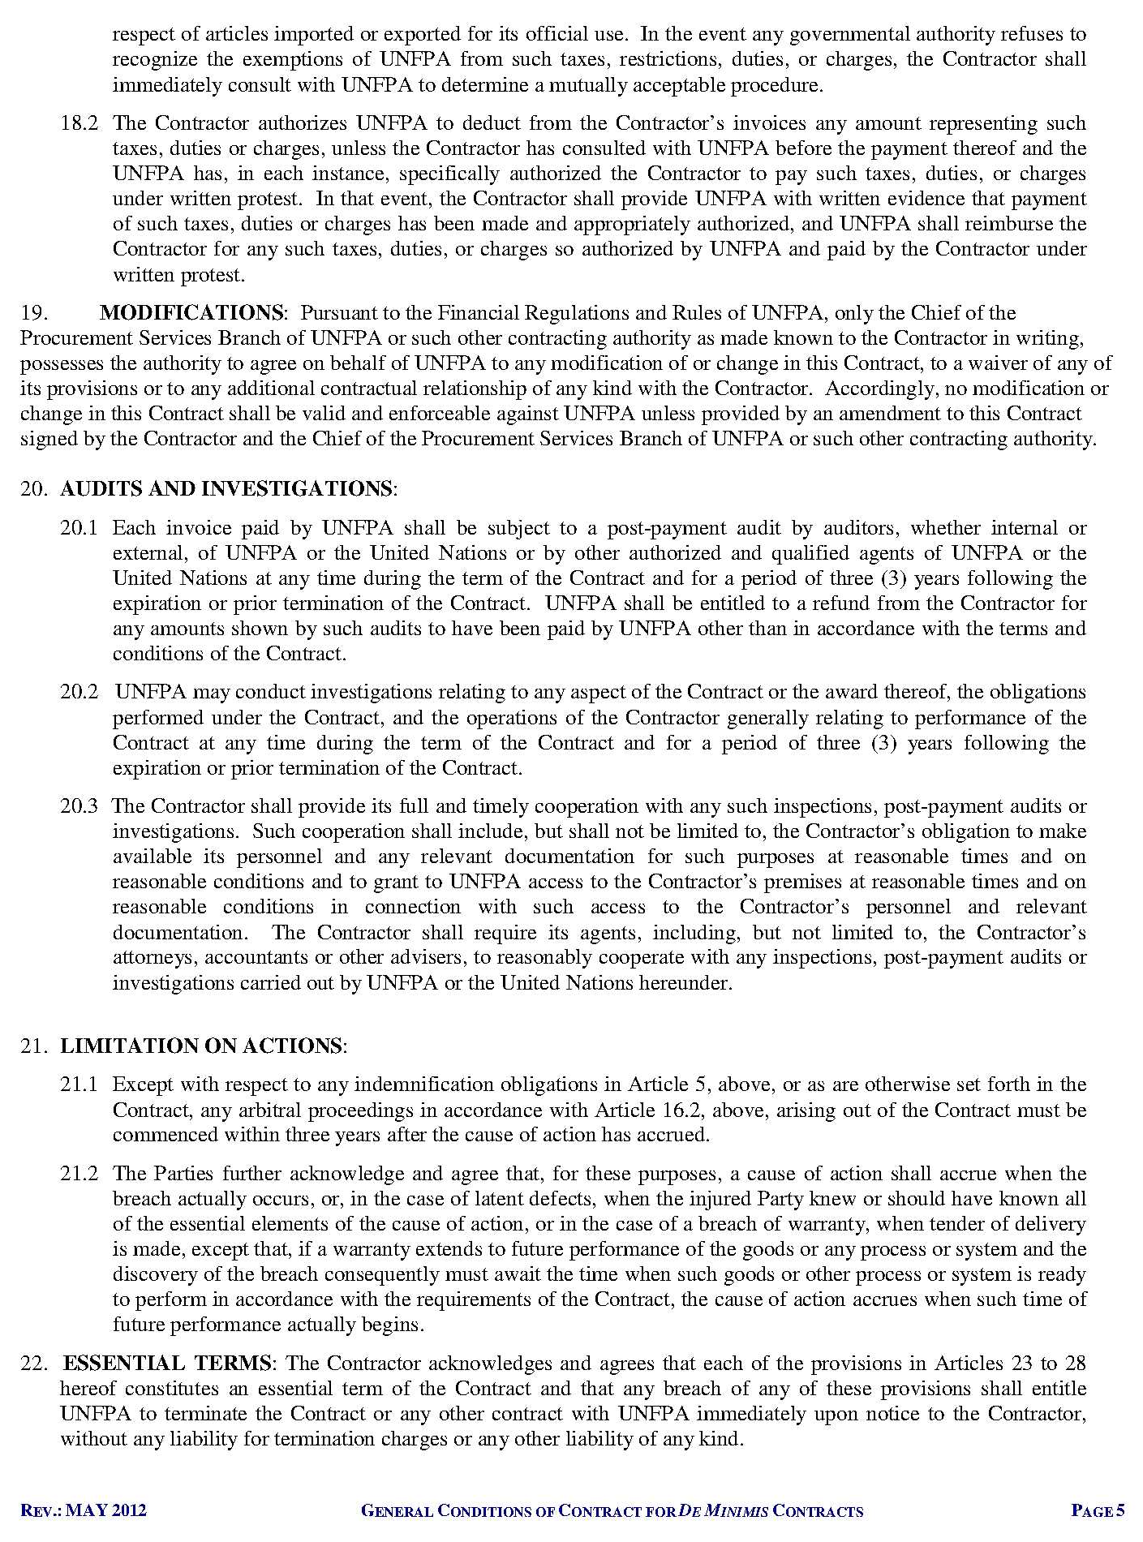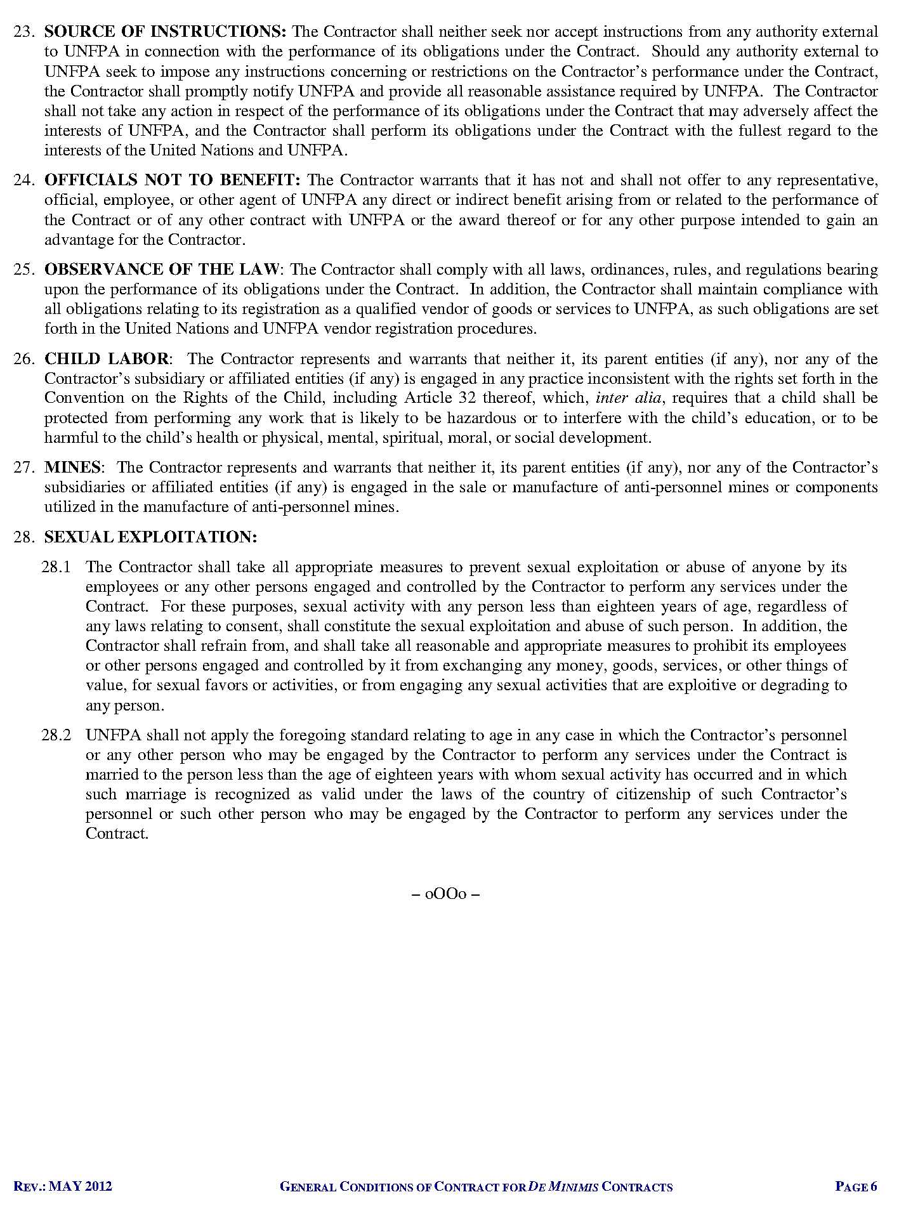

DHS Cambodia 2014
Women’s Health and Life Experiences, WHO, 2015
Adolescent/Youth Situation Analysis, UNFPA, UNICEF, WFP and UNAIDS, 2020
Rapid Assessment on the Social and Health Impact of COVID-19 on Returning Migrant Workers, UNFPA, 2020
Cambodian Migrant Workers’ Mental Health Status and Life during COVID-19 in Thailand, 2020

