Date: 28 July 2021

REQUEST FOR QUOTATION

RFQ Nº UNFPA/KHM/RFQ/21/012

Dear Sir/Madam,

UNFPA hereby solicits a quotation for the following items:

|  |  |  |  |  |
| --- | --- | --- | --- | --- |
| **Item N°** | **Product Name** | **Product Description** | **Unit of Measure** | **Quantity** |
| *01~11* | ***See Enclosed Details:***   * *The list of ICT Equipment and Accessories;*   *.*   * *Office Electronic Materials.* | ***The items to be used by:***   * *Ministry of Health;* * *Ministry of Women’s Affairs;* * *Ministry of Planning;* * *Ministry of Education, Youth and Sports.* | *See Enclosed:* | |

***\*Item not in LTA, not in stock, marking Expected Date of Delivery clearly***

Cambodia country office has planned to purchase ICT Equipment for our Implementing Partners in 2021. The procurements’ Purchase Orders will be split into two modalities:

1. LTA and Non-LTA.
2. In-Stocks and Not In-Stock.

Following specifications are requiring:

1. *Windows with proper licensed from company*
2. *"RJ-45 Ethernet connection" on the laptop.*

*The suppliers can add USB-C to Ethernet adapter to pass this criterion.*

1. *An external Docking system, a mouse to be used in the office (according to requests).*
2. *Warranty terms: Accidental damage, Additional battery warranty, Next business day, etc if possible and must state clearly.*

**Computer Laptop (ENG Keyboard) with below specifications:**

|  |  |
| --- | --- |
| * 5th Gen Intel Mobile Core i5 or equivalent * At least Quad-Core Processor with at least 1.6 GHz speed and at least 6MB cache * At least 8GB DDR4 Memory (One piece) * At least 512GB Solid State Drive * Dual-Band Wireless 802.11ac * Gigabit Ethernet network interface * 1 Thunderbolt version 3 * 1 Audio combo port * 2 USB version 3.1 port * 1 HDMI port * 1 Memory Card Reader port * Lock Slot * Wide Screen 13"-14" FHD Anti-Glare * Integrated HD Graphics | * At least 4 cell Lithium-Ion battery * Build-in English Keyboard * External USB Mouse * AC Adapter with US Power Cord * Webcam * Speaker & Noise Cancelling Digital Array Mic * Docking station * Backpack for laptop * Preload Windows 10 Professional 64bit * At least 3 years battery warranty * At least 4 years warranty, including accidental damage for Laptop and Docking station * Next business day onsite service warranty * Brands: Lenovo, HP, Dell, Toshiba, and Sony * Windows License |

**Computer Desktop (ENG Keyboard) with below specifications:**

|  |  |
| --- | --- |
| * 5th Gen Intel Core i5 or euivalent * Front Side Bus: 2.7 GHz * RAM: 8GB, NON-ECC, 1600MHZ DDR3,   2DIMM. Systems developers and power users  may need computers with larger RAM   * Hard Disk: 500GB 7200rpm (Keep Your   Hard Drive, 3 Year)   * CD-ROM: 16X DVD+/-RW * External Ports: 4 USB 2.0/ 3.0 * Graphics: Integrated, up to 256MB shared * Sound: Integrated * Monitor: 21" WXGA LCD | * Keyboards: 101 key-enhanced keyboard * Mouse: 2 button digital mouse with scroll * Operating System: Windows 7 Professional (64 bit) * Network Capability: Integrated 10/100/1000 Ethernet card * Windows 10 Professional (64 bit) * Warranty: 3 Years onsite (next business day recommended) * Brands: Lenovo, Dell, Hewlett-Packard * Windows License. |

This Request for Quotation is open to all legally-constituted companies that can provide the requested products/services/ and have legal capacity to deliver/perform in the country, or through an authorized representative.

1. **About UNFPA**

UNFPA, the United Nations Population Fund (UNFPA), is an international development agency that works to deliver a world where every pregnancy is wanted, every child birth is safe and every young person’s potential is fulfilled.

UNFPA is the lead UN agency that expands the possibilities for women and young people to lead healthy sexual and reproductive lives. To read more about UNFPA, please go to: [UNFPA about us](http://www.unfpa.org/about-us)

**Objective:**

The objective of the RFQ is to identify a supplier who can provide UNFPA with all the above mentioned products. The selected vendor is expected to provide such products, based on specific Purchase Orders submitted to the vendor.

1. **Questions**

Questions or requests for further clarifications should be submitted in writing to the contact person below:

|  |  |
| --- | --- |
| Name of contact person at UNFPA: | Mr. Sophoan Livan |
| Mobile Nº: | 855 12 728 822 |
| 855 69 822 125 |
| Email address of contact person: | cambodia-procurement@unfpa.org |

The deadline for submission of **questions** is **10th of August 2021 at 17:00 Hrs. Phnom Penh time**[1]. Questions will be answered in writing and shared with all parties as soon as possible after this deadline.

1. **Content of quotations**

Quotations should be submitted in a single email whenever possible, depending on file size. Quotations must contain:

1. Technical proposal, in response to the requirements outlined in the specifications should comply with:
   * The bidder shall be required to quote for all items.
2. Price quotation, to be submitted strictly in accordance with Price Quotation Form.

Both parts of the quotation must be signed by the company’s relevant authority and submitted in PDF format.

1. **Instructions for submission**

Proposals should be prepared based on the guidelines set forth in Section III above, along with a properly filled out and signed price quotation form, and are to be sent by email to the contact person indicated below no later than: **12th of August 2021 at 12:00 Noon. Phnom Penh time**[2].

|  |  |
| --- | --- |
| Name of contact person at UNFPA: | Mr. Sophoan Livan |
| Email address of contact person: | cambodia-procurement@unfpa.org |

Please note the following guidelines for electronic submissions:

* The following reference must be included in the email subject line: RFQ Nº UNFPA/KHM/RFQ/21/012– ICT Equipment Proposals that do not contain the correct email subject line may be overlooked by the procurement officer and therefore not considered.
* The total email size may not exceed **20 MB (including email body, encoded attachments and headers)**. Where the technical details are in large electronic files, it is recommended that these be sent separately before the deadline.
* Any quotation submitted will be regarded as an offer by the bidder and does not  
  constitute or imply the acceptance of any quotation by UNFPA. UNFPA is under no obligation to award a contract to any bidder as a result of this RFQ.

1. **Overview of Evaluation Process**

Quotations will be evaluated based on the compliance with the technical specifications and the total cost of the goods (price quote).

The evaluation will be carried out in a two-step process by an ad-hoc evaluation panel. Technical proposals will be evaluated for technical compliance prior to the comparison of price quotes.

1. **Award**

In case of a satisfactory result from the evaluation process, UNFPA shall award a Purchase Order with duration of 6 months (Six months) to the lowest priced bidder whose bid has been determined to be substantially compliant with the bidding documents.

1. **Right to Vary Requirements at Time of Award**

UNFPA reserves the right at the time of award of Contract to increase or decrease, by up to 20%, the volume of goods specified in this RFQ without any change in unit prices or other terms and conditions.

1. **Payment Terms**

UNFPA payment terms are net 30 days upon receipt of shipping documents, invoice and other documentation required by the contract.

1. [**Fraud and Corruption**](http://www.unfpa.org/about-procurement#FraudCorruption)

UNFPA is committed to preventing, identifying, and addressing all acts of fraud against UNFPA, as well as against third parties involved in UNFPA activities. UNFPA’s Policy regarding fraud and corruption is available here: [Fraud Policy](http://www.unfpa.org/resources/fraud-policy-2009#overlay-context=node/10356/draft). Submission of a proposal implies that the Bidder is aware of this policy.

Suppliers, their subsidiaries, agents, intermediaries and principals must cooperate with the UNFPA Office of Audit and Investigations Services as well as with any other oversight entity authorized by the Executive Director and with the UNFPA Ethics Advisor as and when required.  Such cooperation shall include, but not be limited to, the following: access to all employees, representatives agents and assignees of the vendor; as well as production of all documents requested, including financial records.  Failure to fully cooperate with investigations will be considered sufficient grounds to allow UNFPA to repudiate and terminate the Agreement, and to debar and remove the supplier from UNFPA's list of registered suppliers.

A confidential Anti-Fraud Hotline is available to any Bidder to report suspicious fraudulent activities at [UNFPA Investigation Hotline](http://web2.unfpa.org/help/hotline.cfm).

1. **Zero Tolerance**

UNFPA has adopted a zero-tolerance policy on gifts and hospitality. Suppliers are therefore requested not to send gifts or offer hospitality to UNFPA personnel. Further details on this policy are available here: [Zero Tolerance Policy](http://www.unfpa.org/about-procurement#ZeroTolerance).

1. **RFQ Protest**

Bidder(s) perceiving that they have been unjustly or unfairly treated in connection with a solicitation, evaluation, or award of a contract may submit a complaint to the UNFPA Acting Representative at dalemu@unfpa.org. Should the supplier be unsatisfied with the reply provided by the UNFPA Head of the Business Unit, the supplier may contact the Chief, Procurement Services Branch at [procurement@unfpa.org](mailto:procurement@unfpa.org).

1. **Disclaimer**

Should any of the links in this RFQ document be unavailable or inaccessible for any reason, bidders can contact the Procurement Officer in charge of the procurement to request for them to share a PDF version of such document(s).

PRICE Quotation Form

|  |  |
| --- | --- |
| **Name of Bidder:** |  |
| **Date of the quotation:** | Click here to enter a date. |
| **Request for quotation Nº:** | UNFPA/KHM/RFQ/21/012 |
| **Currency of quotation:** | USD |
| **Delivery charges based on the following 2010 Incoterm:** | Choose an item. |
| **Validity of quotation:**  *(The quotation shall be valid for a period of at least 3 months after the submission deadline.)* | |

* Quote VAT 10% separately

|  |  |  |  |  |  |  |
| --- | --- | --- | --- | --- | --- | --- |
| **Item** | **Product Name & Description** | | **UOM** | **Unit Price** | **Number of Units** | **Total**  **(USD)** |
| *1* |  | |  |  |  |  |
| *2* |  | |  |  |  |  |
| *3* |  | |  |  |  |  |
| *4* |  | |  |  |  |  |
| *5* |  | |  |  |  |  |
| *6* |  | |  |  |  |  |
| 7 |  | |  |  |  |  |
| 8 |  | |  |  |  |  |
| 9 |  | |  |  |  |  |
| 10 |  | |  |  |  |  |
| 11 |  | |  |  |  |  |
|  | Delivery Charges based on the following 2010 Incoterm, to: | Choose an item. | Each |  | 1 |  |
| **Room No. 526, 5th Floor,**  **Phnom Penh Center**  **Sangkat Tonle Basac, Khan Chamka Mon** | |
| **GRAND TOTAL** | | | | | |  |

|  |
| --- |
| *Vendor’s Comments:* |

I hereby certify that the company mentioned above, which I am duly authorized to sign for, has reviewed RFQ UNFPA/KHM/RFQ/20/005 including all annexes, amendments to the RFQ document (if applicable) and the responses provided by UNFPA on clarification questions from the prospective service providers. Further, the company accepts the General Conditions of Contract for UNFPA and we will abide by this quotation until it expires.

|  |  |  |
| --- | --- | --- |
|  | Click here to enter a date. |  |
| Name and title | Date and place | |

**ANNEX I:**

**General Conditions of Contracts:**

**De Minimis Contracts**

This Request for Quotation is subject to UNFPA’s General Conditions of Contract: De Minimis Contracts, which are available in: [English,](http://www.unfpa.org/resources/unfpa-general-conditions-de-minimis-contracts) [Spanish](http://www.unfpa.org/sites/default/files/resource-pdf/UNFPA%20General%20Conditions%20-%20De%20Minimis%20Contracts%20SP_0.pdf) and [French](http://www.unfpa.org/sites/default/files/resource-pdf/UNFPA%20General%20Conditions%20-%20De%20Minimis%20Contracts%20FR_0.pdf) (Separate File)

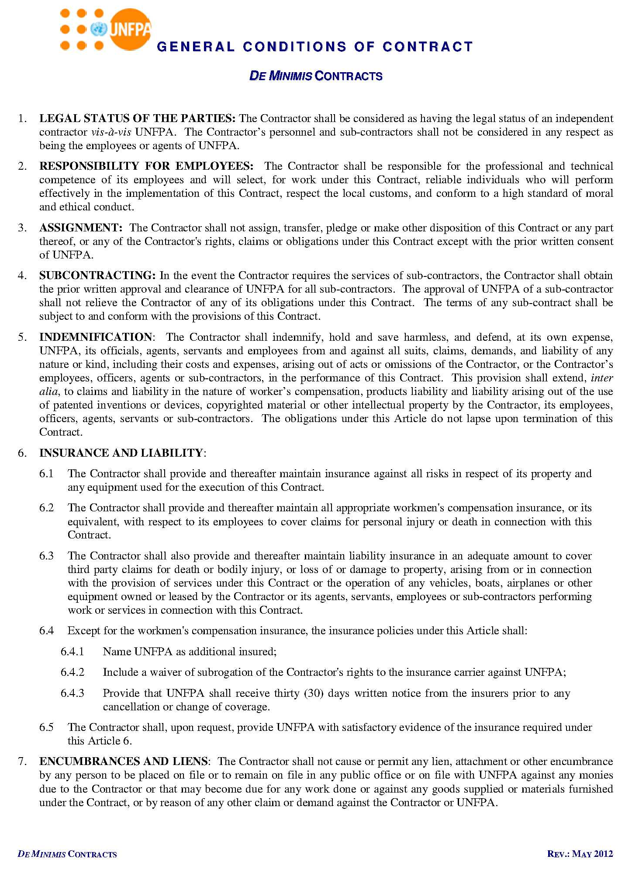

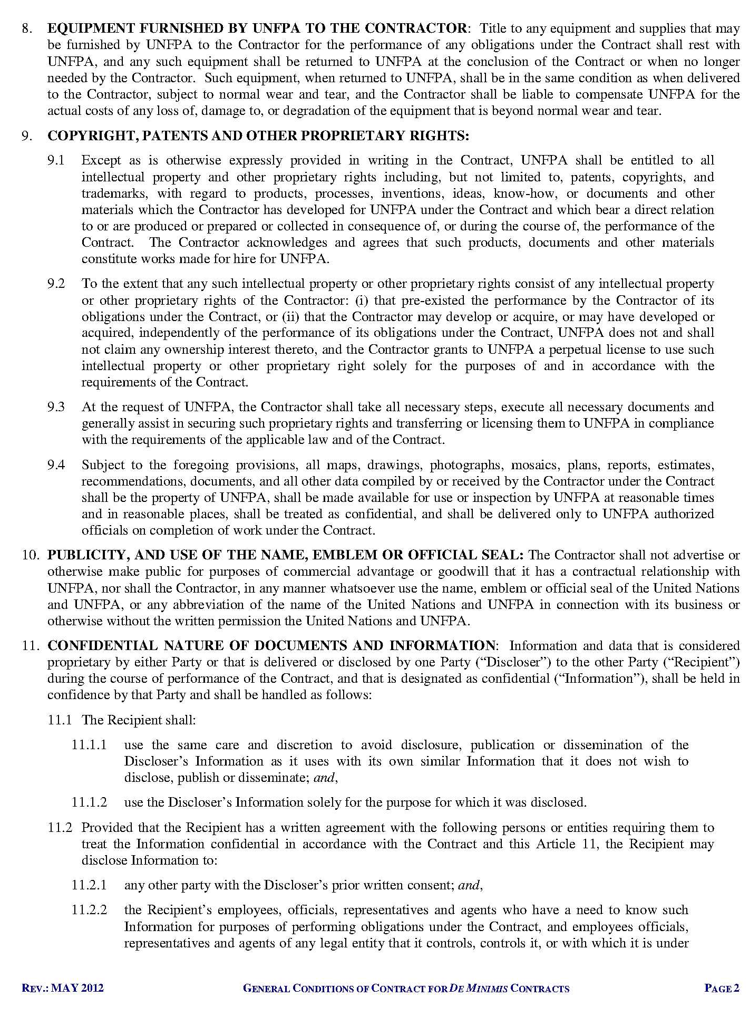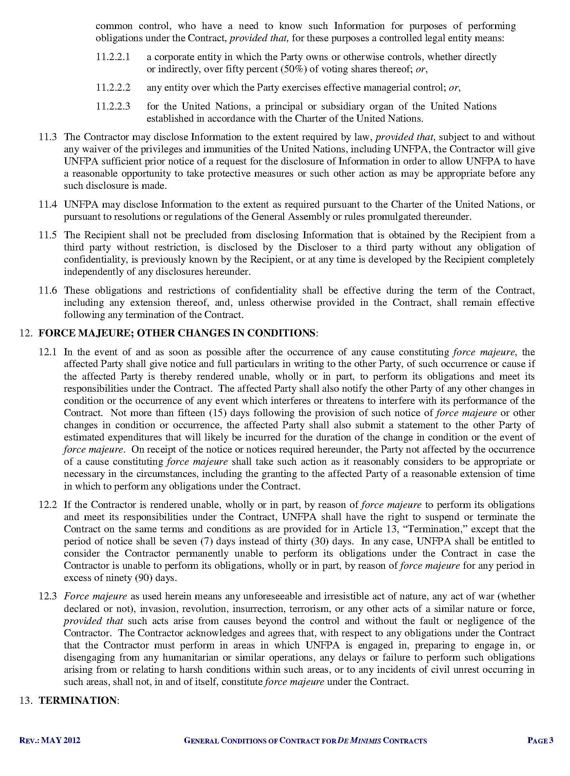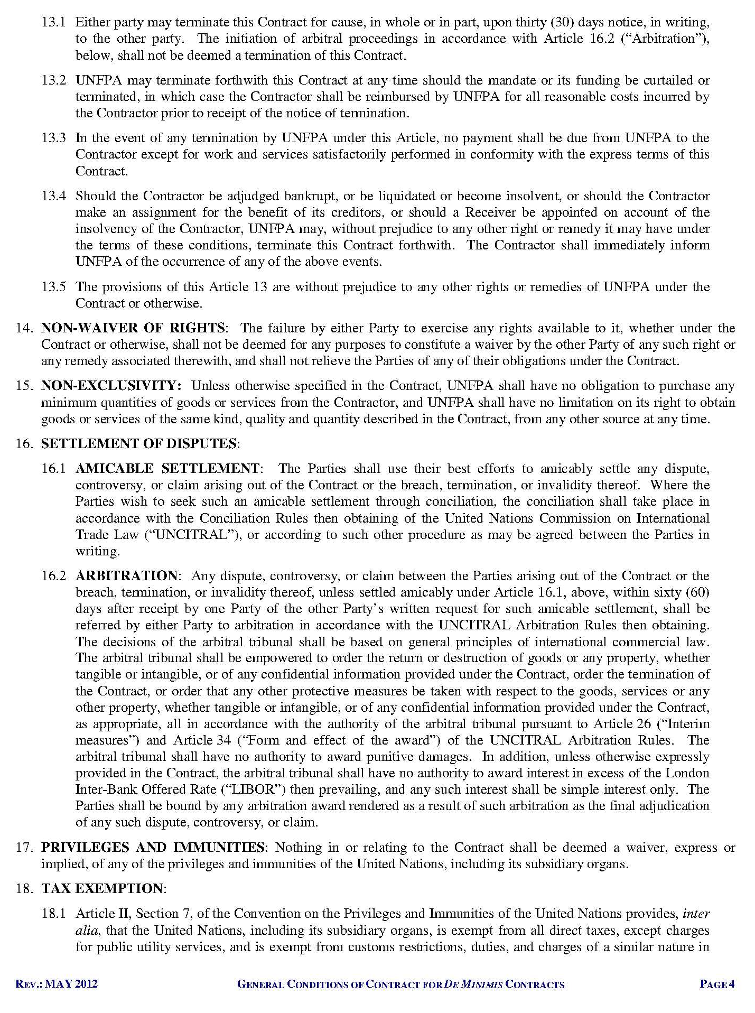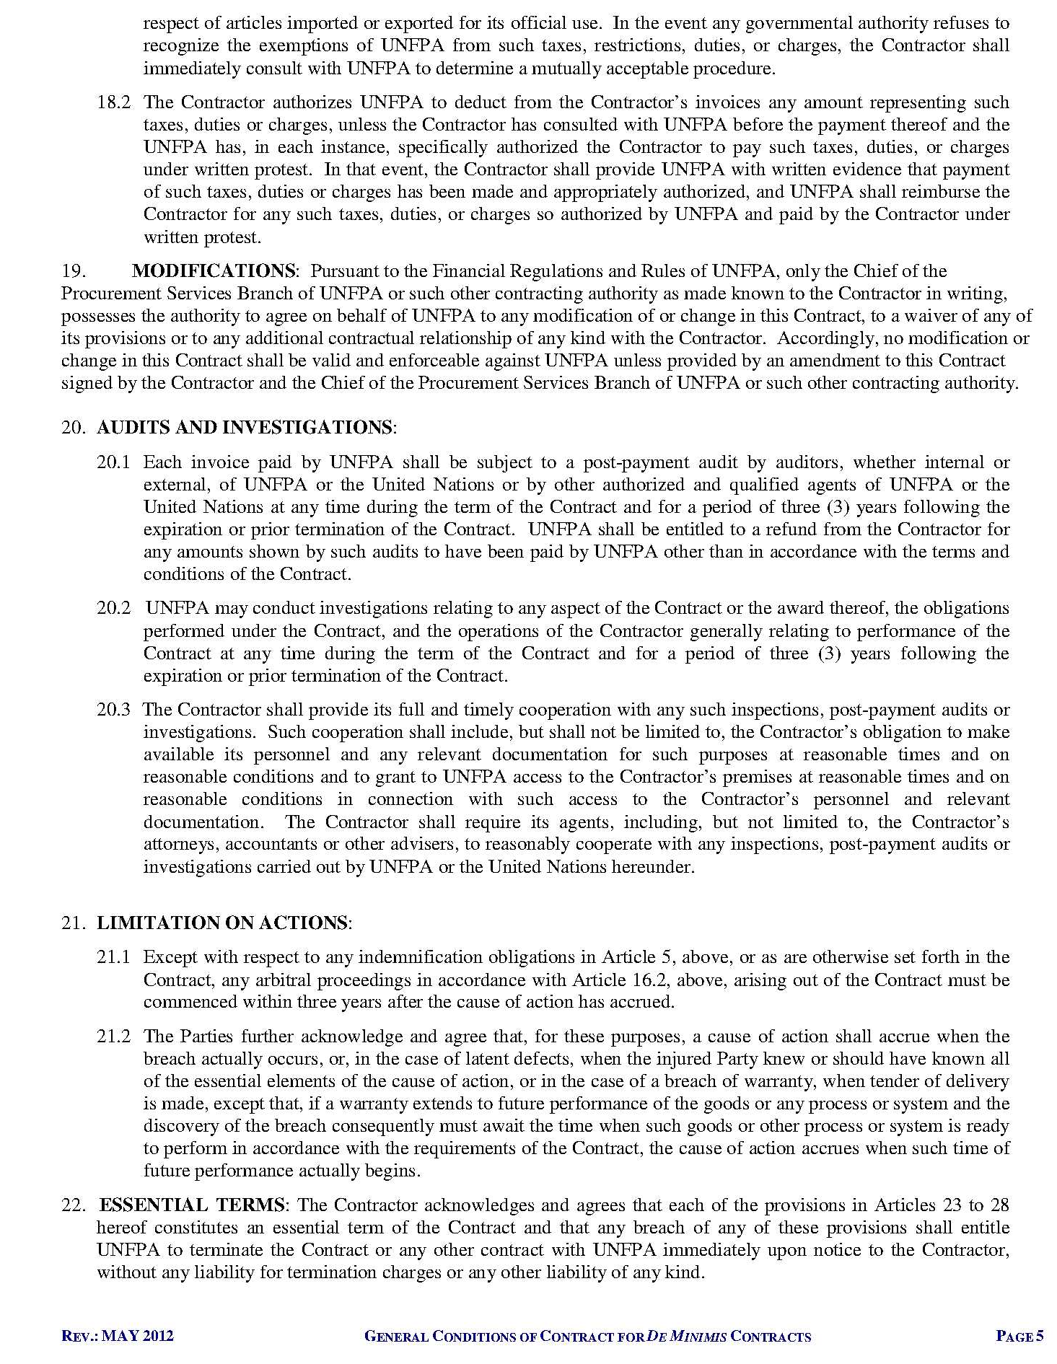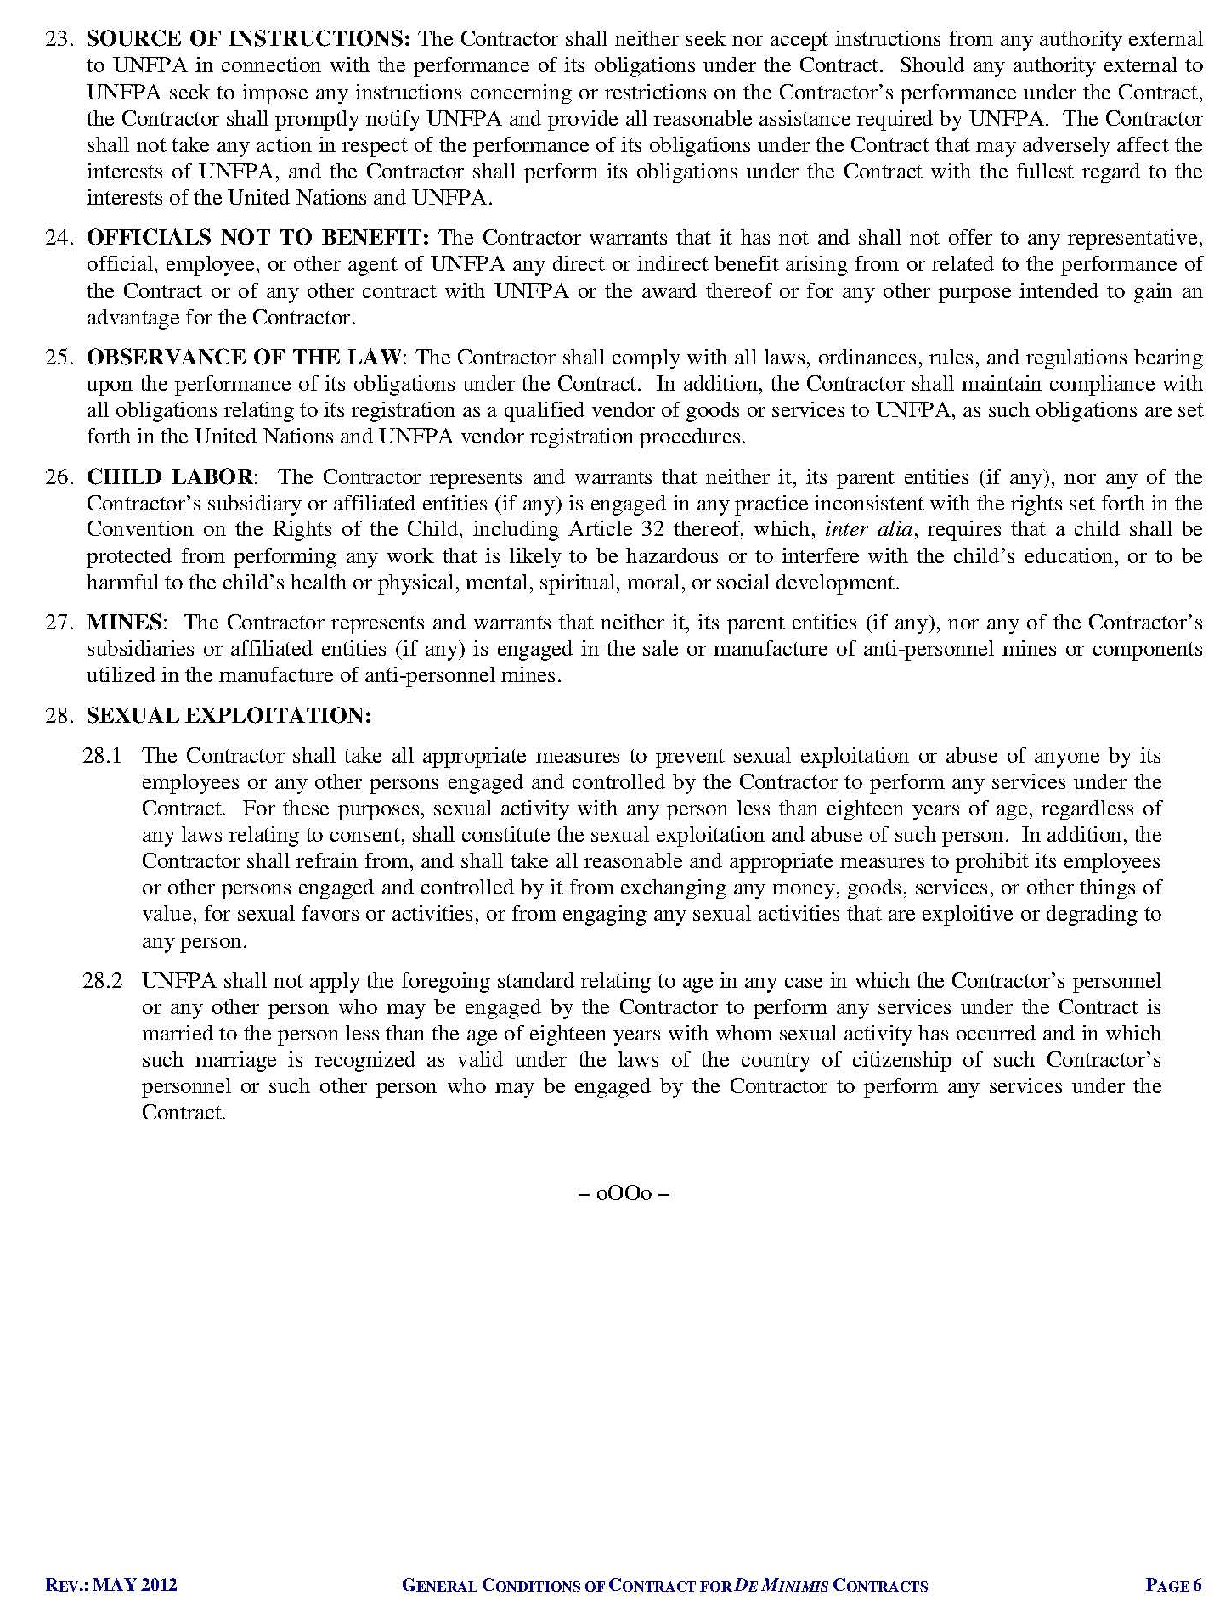

1. [*http://www.timeanddate.com/worldclock/city.html?n=69*](http://www.timeanddate.com/worldclock/city.html?n=69)
2. [*http://www.timeanddate.com/worldclock/city.html?n=69*](http://www.timeanddate.com/worldclock/city.html?n=69)