Date: 8 June 2022

REQUEST FOR QUOTATION
RFQ Nº UNFPA/KHM/RFQ/22/005

Dear Sir/Madam,

UNFPA hereby solicits a quotation for the following service:

“To develop an interactive Chatbot and SAFE APP for women and girls responding to GBV/VAW in Cambodia”.

UNFPA requires the provision of developing GBV digital platforms, which will be the interface and connection between the users and the national system to interact with rights holders to service coordinated by MOWA. It aims to explore technological solutions to address and enhance service information through the Facebook (FB) messenger Chatbot and mobile application to strengthen the accessibility and availability of essential services package for women and girls who have experienced GBV/VAW.

- About UNFPA

UNFPA, the United Nations Population Fund (UNFPA), is an international development agency that works to deliver a world where every pregnancy is wanted, every child birth is safe and every young person’s potential is fulfilled.

UNFPA is the lead UN agency that expands the possibilities for women and young people to lead healthy sexual and reproductive lives. To read more about UNFPA, please go to: UNFPA about us

Service Requirements/Terms of Reference (ToR)

Background and rationale of the project
It has been 27 years since UNFPA supported the Royal Government of Cambodia (RGC) in addressing gender norms and GBV, enhancing sexual and reproductive health for adolescents and youth, and improving sexual reproductive health and rights of women, girls, and individuals. The GBV and sexual harassment are ones of the priority areas in UNFPA Country Program Action Plan 2019-2023. UNFPA has provided technical support to the Ministry of Women Affairs (MoWA) to achieve their strong and progressive pledge through the National Commitments made at the International Conference on Population and Development +25 (ICPD25) Nairobi Summit in 2019. The National Commitments made at the Nairobi Summit seek to achieve the three Transformative Results: Zero Unmet need for family planning, Zero preventable maternal deaths, and Zero Gender-Based Violence (GBV) and harmful practices by ensuring that ALL women and girls in Cambodia have equal access to quality and comprehensive GBV prevention, information and services by no later than 2030. However, critical gaps remain as highlighted in the National Action Plan to Prevent Violence Against Women (NAPVAW) 2019 – 2023; human, technical and financial resources required to successfully implement that plan have not been allocated.
In Cambodia, the number of calls to violence hotlines after the lockdown in March 2021 increased seven times compared to before November 2020. The internet searches to seek information for survivors increased by 52 percent compared to previous year. Moreover, searches for mental health increased by 39%, and general searches about mental health symptomatology (such as “depression” or “anxiety”) increased by 19% across the duration reviewed. Help-seeking searches such as “how to heal from trauma” or “counseling near me” increased by 17%2. Women and girls, particularly those with additional vulnerabilities such as out-of-school, unemployed, people with disabilities, or migrant youth may be experiencing higher exposure to violence since the onset of the COVID-19 pandemic. Worse still, not all Gender Based Violence survivors are able to access the services they need. In Cambodia, a number of laws, policies and strategies have been introduced and various GBV response services have been established. However, only 24 percent of women experiencing physical or sexual intimate partner violence seek help from formal service providers. While they are seeking information and services, there are not enough reliable online resources and systems, which provide actionable steps and coordinate existing support for them. User-friendly system for survivors and victims is required to help them access information and use the helpline services. Currently, the reporting system is through the Child Help Line - 1280 and the hotline 1288 which is used for human trafficking and GBV issues and recently, MoWA provide the two helpline numbers–093 777900/085 777900 for gender and GBV issues.
The proliferation and innovative use of digital technology give young people, women and girls more opportunities than ever before. In the context of Cambodia, approximately 60 per cent of young people aged 15-24 have access to mobile phones and regular access to the internet in urban areas. Most young people reported it is also used to stay connected with friends and relatives through social media and messaging apps 90 per cent. Women, girls and GBV survivors use social media, particularly Facebook as a search engine to obtain Khmer or local information against the overall number of Facebook account users in Cambodia, estimated around 10.9 million.

Objective of the assignment
In this context, UNFPA supports MoWA in developing GBV digital platforms, which will be the interface and connection between the users and the national system to interact with rights holders to service coordinated by MOWA. It aims to explore technological solutions to address and enhance service information through the Facebook (FB) messenger Chatbot and mobile application to strengthen the accessibility and availability of essential services package for women and girls who have experienced GBV/VAW survivors as well as women and girls.

- Specific Objectives
1- To establish a functioning Chatbot/automatic reply system Artificial Intelligence (AI) (text and voice display in Khmer) to facilitate of which women and girls’ access to can obtain the information on and available essential services for GBV/VAW, and be referred to call centers and services providers when needed, as per their informed consent. The Chatbots will support clients on every stage of the service flow; risk mitigation prevention, identification and provision of the referral services as per the choices expressed by the survivors.
- Development of the 24/7 responsive system
The Chatbot will be integrated into existing MoWA’s FB page and will needs to be available 24/7. Clients can get answers to their questions immediately through AI response system, without a delay, and at any time of the day, which leads to improving clients’ positive experiences and the improvement of promoting multi-sectoral services, led by MOWA. The algorithm will be developed with the technical advice from GBV expert from UNFPA and MoWA to ensure the support is survivor-centred.
- Provision of personalized referral services
The automatic reply system is used not only for answering questions but also facilitating clients' access to the contact directory of the essential GBV response services available in her location, as per her choice. The Chatbot aims to be a friendly platform to obtain the detailed information about GBV/VAW essential services, and support clients’ choices through clear articulation of information on available services, how to access them and the process of referral. The client support will be provided in line with GBV Guiding Principles of Safety, Respect, Confidentiality, Non- Discrimination and Informed Consent.
2- To design and set up a mobile application, “Safe App” for users and MOWA to facilitate services for women and girls seeking GBV response services
- Design of the functions for the mobile App
Based on the need assessment report, design and develop the functions of the Mobile app to enable the users to link with the multi-sectoral support i.e. sending signal, coordination a client-centered tracking administrative system, sharing the available and close services (police, hospital, legal, counseling) with ensuring data privacy and confidentiality of the client. The firm should work with GBV specialist, MoWA and related stakeholders to ensure that the App prioritizes women’s safety and upholds GBV Guiding Principles. The initial target group is factory workers in Phnom Penh. The App should be compatible with Android and iOS.
- Pilot the mobile App
Test the developed App among the initial target, to identify and improve technical glitches or challenges regarding safety and accessibility, UX/UI.
User testing to be done with GBV experts and GBV service providers and not with the public.
Expected outputs
- Chatbot is established and integrated into existing MoWA’s Facebook page
- Mobile application (SAFE APP) is developed and pilot with a control group with GBV service providers using it to assess data privacy and confidentiality, functionality, inclusivity and overall usability of the platform.
- TheNumber of women and girls having used/access to GBV Chatbot and SAFE APP facilitate women and girls access to reliable and quality information on GBV services and safe referral to GBV services as per their expressed choices (informed consent)
- Number of women survivors who reached/accessed the GBV digital platform, were referred to other essential social services.

Deliverables/Activities
Deliverable 1: Inception report and induction
The selected firm will work closely with the GBV specialist to:
- Conduct a desk review to inform content development and identify the frequently asked questions related to GBV/VAW through literature review and interview to hotline/helpline GBV focal points.
- Present an inception report to MoWA and UNFPA (including identifying specific requirement and timeframe)
- Present a work-plan (a detailed digital GBV roadmap) and timeline of the platform development for approval by the MoWA and UNFPA

Deliverable 2: Establishment of the GBV digital platform
- Chatbot
- Set up the platform embedded in the MoWA Facebook messenger (possible to link with all FACEBOOK page of PDoWAs), MoWA’s website, and all possible communication channels, which can be automated i.e. WhatsApp, Telegram and GBV APP (in the process of establishment)
- Support and coordinate with the identified consultant MoWA and UNFPA in preparing and grouping the contents (conversational design, Chatbot flow and a logic tree), including:
- Prepare and group frequently asked questions related GBV/VAW
- Develop and design the auto reply contents according to the users’ questions/cases/stories;
  - Develop natural language model to work on the contents
  - Adapt existing contents from other platforms such as App and website, voice response;
  - Communicate with partners and content owners to obtain the permission to link with Chatbot;
  - Re-formatting of videos, photos, document etc. to meet the Chatbot platform requirements; and
  - Record voice-response in Khmer, or add subtitles to videos if needed;
- Create a Chatbot personal linkage with automatic comments, appropriate for GBV survivors when they post comments during MOWA FB live streams or post contents.
- Ensure data confidentiality and privacy over the Chatbot conversations.

- Mobile Application (SAFE APP)-robust Android and iOS
Drafting a software prototype to facilitate access for users to available services and enhance coordination and communication among service providers. Key considerations should be:
- Inclusion of an easy registration system taking into consideration the privacy and rights of the user. This includes identification of which features or services require sign up or personal information. When a case is being requested for support, the platform should be able to automatically create a unique ID and file for that specific user and survivor in an encrypted way in line with a pre-agreed coding system.
- Build in an informed consent securing mechanism before any providing information or contacting for further in-person services.
- Users should be able to report abuse cases safely and also enable users with the option to report directly to confidential service providers as listed in the information.
- Sending a signal for seeking help (call/send GPS location) to guardians, family members, close friends, police/key service providers.
- Build in GPS identifier to help identify nearby service providers. If a case is being reported in an unknown location, the GPS should be able to route itself within a specific radius to identify nearby facilities for quick response.
- The mobile app should be able to offer options to users to seek health, legal and other essential services without lodging a case with the authorities.
- Provide users with the option of sending a text or voice recording while reporting based on a built in informed consent mechanism.
- No data from the app to be stored in the users’ device.
- Facilitate a one-key cover screen function or exit function.
- Ability to integrate diﬀerent relevant support services and currently established data bases such as GBV dashboard (MoWA), and Chatbot, including to links to service directory.

3. ​Data linkage for the GBV digital platform
- Establish the link with existing online resources and phone numbers i.e. Website/YouTube/ Hotline/ Helpline/APP/Dashboard
- Develop the feedback mechanism of the utilization
- Create and track the users’ profile to generate timely reports;
- Procure and pay for server space/Database and hosting to support more users for year 2022, 2023, and 2024 in the name of MoWA;
- Ensure informed consent procedure and privacy and confidentiality protection. Make a clear plan with the GBV specialist and handover to MoWA.
- Present a list of features and functionalities that the auto reply system should (could) have by undertaking discussions with key users and stakeholders (user-centered design approach) and seek approval from MoWA and UNFPA.

Deliverable 3: Testing and Modification
During and after the establishment of the GBV digital platform, the following activities will be carried out:
- Conduct all testing of the platform (back-end and front-end) with key users, followed by adjustments to address feedback.
- Improve digital platform flow, answers and UX/UI according to the user feedbacks, including transcription and synthesis of information gathered. Analyze information.
- Provide instruction/training on the use of the platform and contents uploading and modification.
- Design one 5-minute tutorial video and a manual on the platform use for administrators and users (introduction video, what does it function and how to use it);
- Provide ongoing technical backup and ensure close consultation with MOWA administrators and technical support from UNFPA in any related technical issues.

Deliverable 4: Monitoring and Evaluation of the GBV digital platform
- Monitor and measure the utilization of the Chatbot and SAFE APP (on-going)
- Produce the report for the output indicators (on-going)
- Prepare the final report and recommendation to increase the number of users, and user’s behaviors on Chatbot and SAFE APP.

Deliverable 5: Special requirement: Technical coordination and Maintenance of the platform
Upon the completion of the above activities, this activity will be carried out in the year 2023:
- Provide ongoing maintenance of the platform for the whole year 2023 and 2024, including smooth operation and fixing bugs until the technical handover is completed.
- Designate a technical coordination and logistic staff to support the whole development process of the platform in closely work with the GBV expert, including facilitating content development in Khmer and English, project management support in the area of gender/GBV/development sector, during the development and roll-out process in close consultation with UNFPA.

Timeframe and Payment
The assignment will commence upon signing the contract and be expected to complete by 31 May 2024. Contracted firm will work closely with UNFPA and GBV experts. Work will be monitored by UNFPA and timely updates are required to be sent to UNFPA and MoWA. The tentative time frame below could be adjusted based on the inception report and consultation with UNFPA and MoWA.
- Deliverable 1: Complete the inception report and induction (15 July 2022)
- Deliverable 2: Draft the GBV digital platform (Chatbot and mobile application) (15 November 2022)
- Deliverable 3: Testing and Modification (28 February 2023)
- Deliverable 4: Monitoring and Evaluation of the Chatbot utilization and App dashboard (January 2023-April 2023)
- Deliverable 5: Special requirement: Technical coordination and Maintenance of the platform (July 2022-May 2024)
The Service Provider shall be paid upon completion of the following milestones:
- 40% after the adoption of the inception report and draft of the GBV digital platform (Deliverable 1&2).
- 40% after testing, and modification (Deliverable 3)
- 20% ongoing technical coordination and maintenance commitment (Deliverable 4 & 5) and after handover the completed products and coding resources.

The service provider fee will be paid as a lump sum amount (all-inclusive of expenses related to this project, and any tax obligations). The contract price will be fixed regardless of changes in the cost components.
The total financial proposal shall not exceed USD 70,000.
Competencies: Skills, knowledge and experience required
It is anticipated that the institution/company/firm possesses a minimum of ten years’ experience in application development, the advanced skill of technology and knowledge production and/or academic innovative development in the field of IT, with a distinct knowledge on gender equality and GBV being considered a strong advantage. The institution/company/firm must have professional experience of a team leader and the staff in application development, digital innovation with demonstrated knowledge and expertise in gender/GBV information and services (with their latest CVs).
A coalition of institutions/organizations is also eligible to apply, although contractual arrangements will be made between UNFPA and a single prime entity only. Therefore, in this case, the application must indicate who will be the prime party for the contract/project management, while relevant publications from all members of the consortium will have to be included in the application package.
Qualifications
The institution/company/firm must offer the following demonstrated experience, knowledge and competencies, and knowledge of the UN and development issues:
- Significant knowledge and experience of application development including the Chatbot
- Previous work in developing similar online platform will be an advantage
- Facilitation skills and skills in involvement of diverse and inter-disciplinary stakeholders and shall assign a supervisor to coordinate all work performance. The supervisor shall conduct the quality assurance/check to insure compliance with the required work.
- The Contractor shall be exclusively and totally responsible for the fulfillment of all obligations of his/her employees assigned to the current assignment for MoWA and UNFPA.
- Proven staff capacity in the areas of knowledge, skills, information and services on Gender/GBV in order to assist in the content development is required.
- Experience working with the government and managing digital platforms will be an added advantage.

- Questions
Questions or requests for further clarifications should be submitted in writing to the contact person below:

Name of contact person at UNFPA: | Ms. Sokroeun Aing
Tel Nº: | 855 23 215519-118
Mobile Nº: | 855 12 575 161
Email address of contact person: | aing@unfpa.org

The deadline for submission of questions is 27 June 2022 at 17:00 Hrs. Phnom Penh time. Questions will be answered in writing and shared with parties as soon as possible after this deadline.

- Eligible Bidders

This Request for Quotation is open to all eligible bidders; to be considered an eligible bidder for this solicitation process you must comply with the following:

- A bidder must be a legally-constituted company that can provide the requested services and have legal capacity to enter into a contract with UNFPA to deliver/perform in the country, or through an authorized representative.
- A bidder must not have a conflict of interest regarding the solicitation process or with the TORs. Bidders found to have a conflict of interest shall be disqualified.
- At the time of Bid submission, the bidder, including any JV/Consortium members, is not under procurement prohibitions derived from the Compendium of United Nations Security Council Sanctions Lists and has not been suspended, debarred, sanctioned or otherwise identified as ineligible by any UN Organization or the World Bank Group.
- Bidders must adhere to the UN Supplier Code of Conduct, which may be found by clicking on UN Supplier Code of Conduct.

- Content of quotations
Quotations should be submitted via a TWO-envelope system. Interested Bidders are requested to submit their Technical Bid separately from their Financial Bid containing the price information. Each envelope shall consist of a single email whenever possible, depending on file size.

- Technical proposal, in response to the requirements outlined in the service requirements / TORs.
- Price quotation, to be submitted strictly in accordance with the price quotation form.

Both parts of the quotation must be signed by the bidding company’s relevant authority and submitted in PDF format.

- Instructions for submission
Proposals should be prepared based on the guidelines set forth in Section III above, along with a properly
filled out and signed price quotation form, and are to be sent by email to the address indicated below
below no later than: 1 July 2022 at 17:00 Hrs. Phnom Penh time.

Name of contact person at UNFPA: | Mr. Sophoan Livan
Email address of contact person: | cambodia-procurement@unfpa.org

Please note the following guidelines for electronic submissions:

- The following reference must be included by the Bidder in the email subject line:

  - RFQ Nº UNFPA/KHM/RFQ/22/005 - [Company name], Technical Bid
  - RFQ Nº UNFPA/KHM/RFQ/22/005 - [Company name], Financial Bid
  - Submissions without this text in the email subject line may be rejected or overlooked
and therefore not considered.

- It is the Bidder’s responsibility to assure compliance with the submission process. If the envelopes or emails are not marked / submitted per the instructions, UNFPA will neither assume responsibility for the bid’s misplacement or premature opening nor guarantee the confidentiality of the Bid process. Incorrect submissions might result in your Bid being declared invalid.
- Please do NOT send the emails containing your offer to any other email address (not even as a copy (CC) or blind copy (BCC)); otherwise UNFPA will not be able to guarantee confidentiality and fair and transparent handling of your bid. UNFPA reserves the right to reject bids sent via the appropriate channel but copied or blind copied to other email addresses.
- The total email size may not exceed 20 MB (including email body, encoded attachments and headers). Where the technical details are in large electronic files, it is recommended that these be sent separately before the deadline.
- When submitting electronic offers, Bidders will receive an auto-reply acknowledging receipt of the first email. Should your offer require you to submit more than one email, in the body of this first email, bidders are requested to list the number of messages, which make up their technical offer and the number of messages, which make up their financial offer. If you do not receive any auto-reply for the first email from UNFPA’s email system, please inform Mr. Sophoan Livan at cambodia-procurement@unfpa.org
- Any quotation submitted will be regarded as an offer by the bidder and does not constitute or imply the acceptance of any quotation by UNFPA. UNFPA is under no obligation to award a contract to any bidder as a result of this RFQ.

- Overview of Evaluation Process
The evaluation will be carried out in a two-step process by an ad-hoc evaluation panel. Technical proposals will be evaluated and scored first, prior to the evaluation and scoring of price quotations

Technical Evaluation

Technical proposals will be evaluated based on their responsiveness to the service requirements /TORs listed in Section II and in accordance with the evaluation criteria below.

Criteria | [A] Maximum Points | [B]  Points obtained by Bidder | [C]  Weight (%) | [B] x [C] = [D]  Total Points
Technical approach, methodology and level of understanding of the objectives of the project | 100 |  | 20%
Work plan/time scales given in the proposal and its adequacy to meet the project objectives | 100 |  | 20%
Professional experience of the staff that will be employed to the project proving demonstrated expertise in evaluation and related processes (CVs, etc.) | 100 |  | 15%
Specific experience and expertise relevant to the assignment | 100 |  | 30%
Profile of the company and relevance to the Project. | 100 |  | 15%
Grand Total All Criteria | 500 |  | 100%

The following scoring scale will be used to ensure objective evaluation:

Degree to which the Terms of Reference requirements are met based on evidence included in the Bid submitted | Points  out of 100
Significantly exceeds the requirements | 90 – 100
Exceeds the requirements | 80 – 89
Meets the requirements | 70 – 79
Partially meets the requirements | 1 – 69
Does not meet the requirements or no information provided to assess compliance with the requirements | 0

Financial Evaluation
Price quotes will be evaluated only for bidders whose technical proposals achieve a minimum score of 70 points in the technical evaluation.

Price quotes will be evaluated based on their responsiveness to the price quote form. The maximum number of points for the price quote is 100, which will be allocated to the lowest total price in the quotation. All other price quotes will receive points in inverse proportion according to the following formula:

Financial score = | Lowest quote ($) | X 100 (Maximum score)
 | Quote being scored ($)

Total score
The total score for each proposal will be the weighted sum of the technical score and the financial score. The maximum total score is 100 points.

Total score = 70% Technical score + 30% Financial score

- Award Criteria
In case of a satisfactory result from the evaluation process, UNFPA intends to award a Professional Service Contract on a fixed-cost basis to the Bidder(s) that obtain the highest total score.

- Right to Vary Requirements at Time of Award
UNFPA reserves the right at the time of award of contract to increase or decrease by up to 20% the volume of services specified in this RFQ without any change in unit prices or other terms and conditions.

- Payment Terms
UNFPA payment terms are net 30 days upon receipt of invoice and delivery/acceptance of the milestone deliverables linked to payment as specified in the contract.

- Fraud and Corruption
UNFPA is committed to preventing, identifying, and addressing all acts of fraud against UNFPA, as well as against third parties involved in UNFPA activities. UNFPA’s policy regarding fraud and corruption is available here: Fraud Policy. Submission of a proposal implies that the Bidder is aware of this policy.

Suppliers, their subsidiaries, agents, intermediaries and principals must cooperate with the UNFPA Office of Audit and Investigations Services as well as with any other oversight entity authorized by the Executive Director and with the UNFPA Ethics Advisor as and when required. Such cooperation shall include, but not be limited to, the following: access to all employees, representatives agents and assignees of the vendor; as well as production of all documents requested, including financial records. Failure to fully cooperate with investigations will be considered sufficient grounds to allow UNFPA to repudiate and terminate the Agreement, and to debar and remove the supplier from UNFPA's list of registered suppliers.

A confidential Anti-Fraud Hotline is available to any Bidder to report suspicious fraudulent activities at UNFPA Investigation Hotline.

- Zero Tolerance
UNFPA has adopted a zero-tolerance policy on gifts and hospitality. Suppliers are therefore requested not to send gifts or offer hospitality to UNFPA personnel. Further details on this policy are available here: Zero Tolerance Policy.

- RFQ Protest

Bidder(s) perceiving that they have been unjustly or unfairly treated in connection with a solicitation, evaluation, or award of a contract may submit a complaint to the UNFPA Acting Representative at mulilo@unfpa.org. Should the supplier be unsatisfied with the reply provided by the UNFPA Head of the Business Unit, the supplier may contact the Chief, Procurement Services Branch at procurement@unfpa.org.

- Disclaimer
Should any of the links in this RFQ document be unavailable or inaccessible for any reason, bidders can contact the Procurement Officer in charge of the procurement to request for them to share a PDF version of such document(s).

PRICE QUOTATION FORM

Name of Bidder:
Date of the quotation: | Click here to enter a date.
Request for quotation Nº: | UNFPA/KHM/RFQ/22/005
Currency of quotation : | USD
Delivery charges based on the following 2020 Incoterm: | Choose an item.
Validity of quotation:
(The quotation must be valid for a period of at least 3 months after the submission deadline

- Quoted rates must be exclusive of all taxes, since UNFPA is exempt from taxes.

Example Price Schedule below:

Item | Description | Number & Description of Staff by Level | Hourly Rate | Hours to be Committed | Total
- Professional Fees
Total Professional Fees |  |  |  |  | $$
- Out-of-Pocket expenses
Total Out of Pocket Expenses |  |  |  |  | $$
Total Contract Price  (Professional Fees + Out of Pocket Expenses) |  |  |  |  | $$

I hereby certify that the company mentioned above, which I am duly authorized to sign for, has reviewed RFQ UNFPA/KHM/RFQ/22/005 including all annexes, amendments to the RFQ document (if applicable) and the responses provided by UNFPA on clarification questions from the prospective service providers. Further, the company accepts the General Conditions of Contract for UNFPA and we will abide by this quotation until it expires.
Vendor’s Comments:

 | Click here to enter a date.
Name and title | Date and place

ANNEX I:
General Conditions of Contracts:
De Minimis Contracts

This Request for Quotation is subject to UNFPA’s General Conditions of Contract: De Minimis Contracts, which are available in: English, Spanish and French

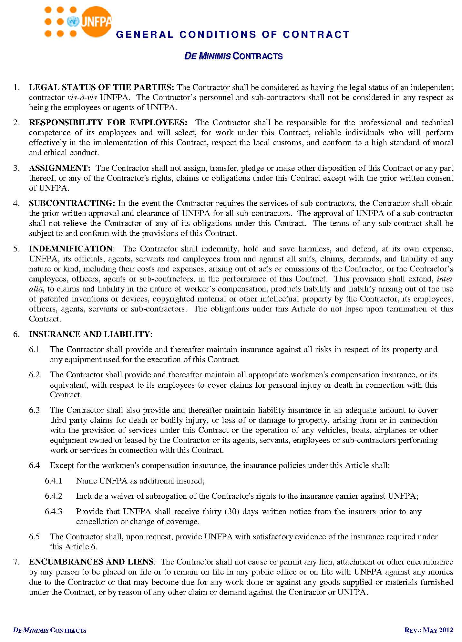
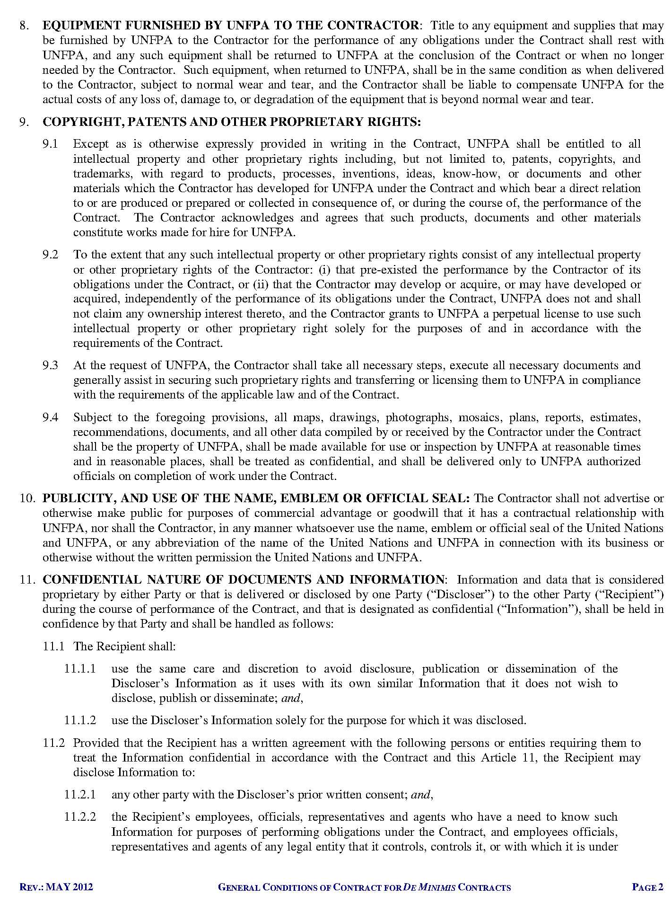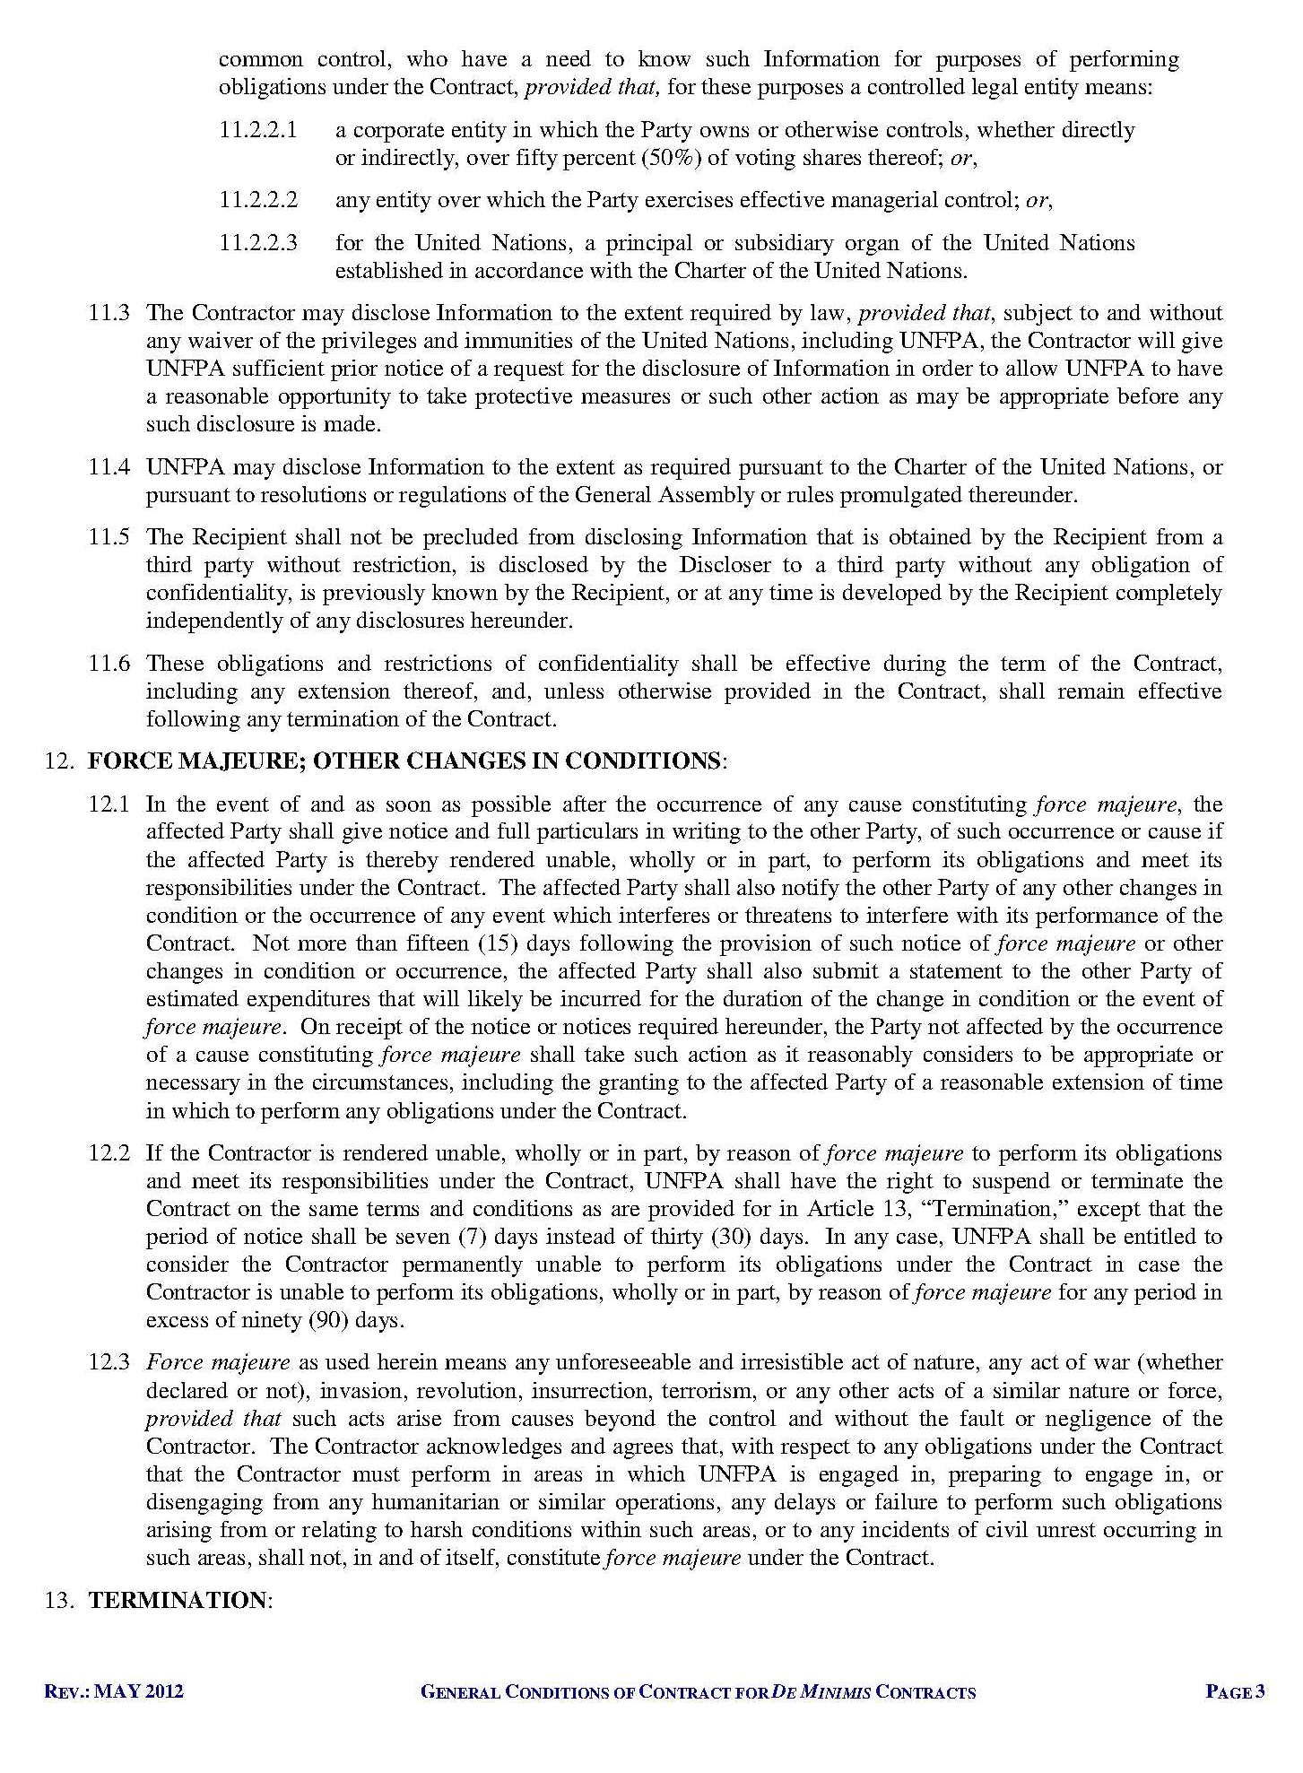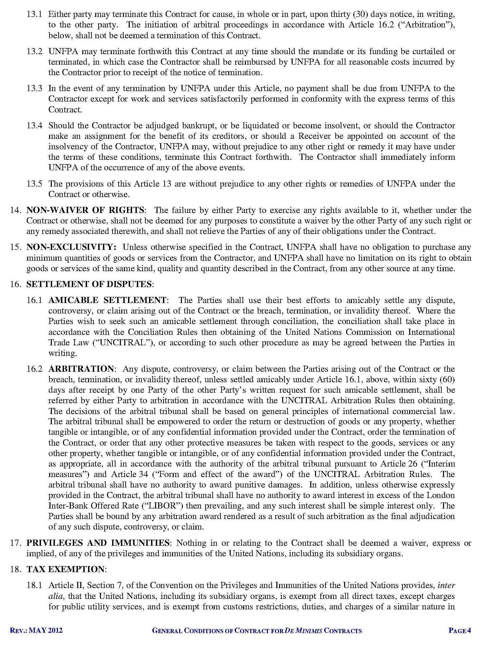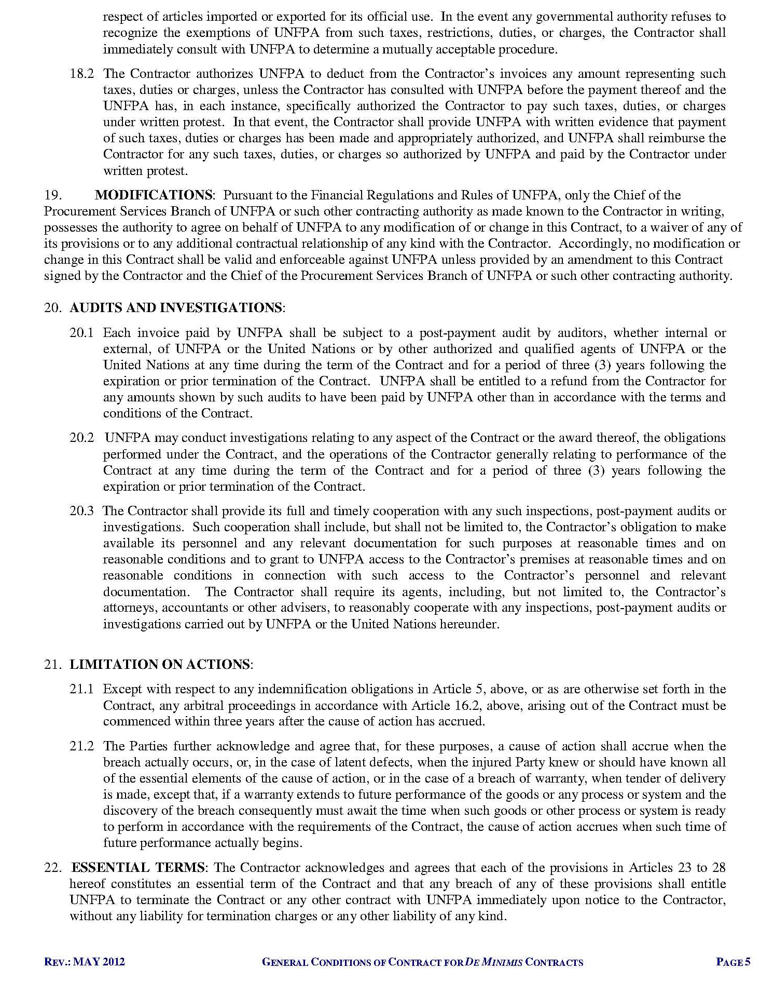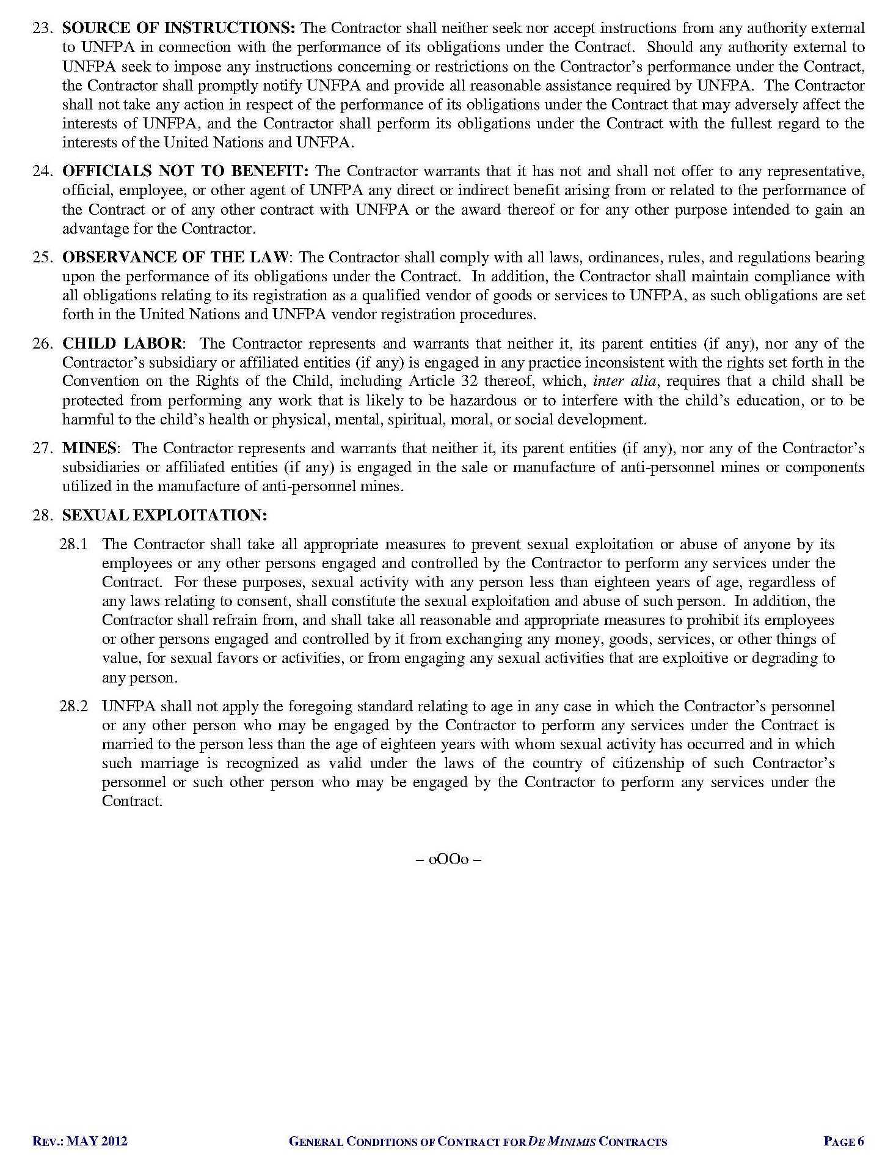

COVID-19 socio-economic impact assessment in Cambodia, May 2021, (joint assessment with UNICEF, UNAIDS, UNFPA, UN Women and WFP)
Big data analysis to assess changes in demand for Gender-Based Violence and mental health Services for survivors, UNFPA September 2021 (draft)
The Adolescent and Youth Situation Analysis in Cambodia, MoYES, UNFPA,WFP, UNICEF, UNAIDS, 2020
NIS, 2015, Women’s Health and Life Experience.
According to figures released by the spokesman for the Telecommunications Regulator of Cambodia, the first half of 2020. https://khmer.rvasia.org
http://www.timeanddate.com/worldclock/city.html?n=69
http://www.timeanddate.com/worldclock/city.html?n=69

